UNIT: I

FOREXMARKET

FEMA: The Foreign Exchange Management Act, 1999 (FEMA), is an Act of the Parliament of India "to consolidate and amend the law relating to foreign exchange with the objective of facilitating external trade and payments and for promoting the orderly development and maintenance of foreign exchange market in India".^{[1]} It was passed on 29 December 1999 in parliament, replacing the Foreign Exchange Regulation Act (FERA).

FERA : The Foreign Exchange Regulation Act (FERA) was legislation passed in India in 1973, FERA came into force with effect from January 1, 1974, FERA imposed strict regulations on certain kinds of payments, the dealings in foreign exchange (forex) and securities and the transactions which had an indirect impact on the foreign exchange and the import and export of currency.^{[5]} The bill was formulated with the aim of regulating payments and foreign exchange
Reason for Change:
FERA did not succeed in restricting activities such as the expansion of Multinational Corporations. The concessions made to FERA in 1991-1993 showed that FERA was on the verge of becoming redundant. After the amendment of FERA in 1993, it was decided that the act would become the FEMA. This was done in order to relax the controls on foreign exchange in India. This led on to invention of beliefs among stakeholders that FEMA and FERA co-exist in present Indian scenario.
FERA was repealed in 1998 by the government of Atal Bihari Vajpayee and replaced by the Foreign Exchange Management Act, which liberalized foreign exchange controls and restrictions on foreign investment.

Scope of Forex Management (Understand the Scope or Area of Forex Management with Simple Examples)
1. An Employee Who is Working in Foreign Company:
A person who is providing service to foreign company and earning salary in foreign currency. He need to manage whether he will convert it in his country's currency today or wait for good time.
2. A Student who is Studying in Foreign Country
A student who went to foreign country for study, needs foreign currency. He has to deposit his own currency into bank and gets foreign currency on the basis of current Forex rate.
3 Banks
Banks also need foreign currency because it earns money by providing foreign exchange currency. For example, if any Indian who has earned $ 3200 from USA will deposit in his bank. Bank will convert in Indian rupees and then bank will get fees for this.
4. Tax Departments
Tax department also included in scope of Forex management because they are interested to get service tax when other country's currency is converted into their own currency.
5. Importers
Forex is also needed for importers. Because they have to pay to foreign country's company for getting their products. So, scope of Forex management. Means when importer will pay. It depends when his country's currency will strong. Otherwise, imports will be costly.
6. Exporters
Exporters will some time gets his sales earning in foreign currency. So, they need to convert into their own currency.

7. Transfer of Profit to Holding Company
If any subsidiary company is working in any foreign currency, it needs to transfer his profit to his holding company in foreign currency. Holding company can also earn profit on Forex if it convert it on the right time.

8. Travelling
If any tourist will will visit any foreign country, he or she need the currency of same country. So, it will convert its own currency from bank.

9. For Doing Forex Business
If you are the Forex dealer, you need to buy or sell forex. So, there is big scope of forex in forex business.

10. Foreign Investment

Our P.M. goes to foreign country. Foreign P.M. comes in our country. They contract for their country's people welfare. So, there will transfer big foreign currency from one country to another country in the form of investment

Fluctuation in the exchange rate
A market based exchange rate will change whenever the values of either of the two component currencies change .A currency willtend to become more valuable when everdemand for it is greater than the available supply. It will become less valuable whenever demand is less than available supply (this does not mean people no longer want money, it just means they prefer holding their wealth in some other form, possibly another currency).

Types of transactions & settlements in FOREX Market
The Foreign Exchange Transactions refers to the sale and purchase of foreign currencies. Simply, the foreign exchange transaction is an agreement of exchange of currencies of one country for another at an agreed exchange rate on a definite date.
- SpotTransaction-The spot transaction is when the buyer and seller of different currencies settle their payments within the two days of the deal. It is the fastest way to exchange the currencies. Here, the currencies are exchanged over a two-day period, which means no contract is signed between the countries. The exchange rate at which the currencies are exchanged is called the Spot Exchange Rate. This rate is often the prevailing exchange rate. The market in which the spot sale and purchase of currencies is facilitated is called a Spot Market.

- Forward Transaction - A forward transaction is a future transaction where the buyer and seller enter into an agreement of sale and purchase of currency after 90 days of the deal at a fixed exchange rate on a definite date in the future. The rate at which the currency is exchanged is called a ‗Forward Exchange Rate‘. The market in which the deals for the sale and purchase of currency at some future date are made is called a ‗Forward Market‘. Future Transaction: The future transactions are also the forward transactions and deals with the contracts in the same manner as that of normal forward transactions. But however, the transactions made in a future contract differ from the transaction made in the forward contract on the following grounds:
  - The forward contracts can be customized on the client‘s request, while the future contracts are standardized such as the features, date, and the size of the contracts is standardized.
  - The future contracts can only be traded on the organized exchanges, while the forward contracts can be traded anywhere depending on the client‘s convenience.
  - No marginis required in case of the forward contracts, while the margins are required of all the participants and an initial margin is kept as collaterals o as to establish the future position.

3) Swap and option Transactions –
The Swap Transactions: It involve a simultaneous borrowing and lending of two different currencies between two investors. Here one investor borrows the currency and lends another currency to the second investor. The obligation to repay the currencies is used as collateral, and the amount is repaid at a forward rate. The swap contracts allow the investors to utilize the funds in the currency held by him/her to pay off the obligations denominated in a different currency without suffering a foreign exchange risk.

Option Transactions - The foreign exchange option gives an investor the right, but not the obligation to exchange the currency in one denomination to another at an agreed exchange rateonapre-defineddate.Anoptiontobuythecurrencyiscalledasa‗CallOption‘whiletheoptiontosellthecurrencyiscalledasaPut Option‘.

Financial Management
In simple terms, financial management is the business function that deals with investing the available financial resources in a way that greater business success and return-on-investment (ROI) is achieved. Financial management professionals plan, organize, and control all transactions in a business. They focus on sourcing the capital whether it is from the initial investment by the entrepreneur, debt financing, venture funding, public issue, or any other sources. Financial management professionals are also responsible for fund allocation in an optimized way to ensure greater financial stability and growth for the organization.

Importance of Financial Management
The financial management of an organization determines the objectives, formulates the policies, lays out the procedures, implements the programmes, and allocates the budgets related to all financial activities of a business. Through a streamlined financial management practice, it is possible to ensure that there are sufficient funds available for the company at any stage of its operations. The importance of financial management can be assessed by taking a look at its core mandate:
- Availability of sufficient funds
- Maintaining a balance between income and expenses to ensure financial stability
- Ensuring efficient and high ROI
- Creating and executing business growth and expansion plans
- Safeguarding the organization against market uncertainties through ensuring buffer funds

Financial Management Scope
Financial management in a company is governed by the principle that it must protect the financial interests of the investors, shareholders, and ensure business growth. Apart from securing their interests, the financial managers are also expected to ensure greater ROI that generates more wealth for all shareholders. There are certain objectives of financial management which are universally accepted by experts and business leaders, and these clearly outline the financial management scope and functions.

Objectives of Financial Management
Certain specific and highly impactful objectives that financial managers aim to attain are:

Assessing Capital Needs
Financial managers need to evaluate factors such as cost of current and fixed assets, cost of marketing, need for buffer capital, long-term operation and human resources cost etc. Successful businesses have clearly defined short-term and long-term financial requirement projections in place.

Determination of Capital Structure
A company’s capital structure is the framework that determines decisions such as debt-equity ratio in the short as well as long term.

Creation of Effective Financial Policies
There is a need to frame efficient financial policies that govern cash control, the lending and borrowing processes and so on.

Resource Optimization
Great financial managers are able to navigate through different scenarios by making optimum use of the available financial resources. This would reduce the cash burn and increase the cash churn to generate maximum ROI.

Functions of Financial Managers and Advisors
To achieve these objectives, the financial managers and advisors must perform certain functions. These include:

Fundraising
For any business to grow confidently and have a good market reputation, adequate amount of cash and liquidity is critical. Therefore, businesses raise funds by equity or debt financing. Financial managers take decisions on maintaining a healthy balance between debt and equity to ensure that the company’s financial health is not impacted.

Fund Allocation
Smart fund allocation is as critical to a business’ financial health as fund-raising itself. The funds that a company has must be allocated in the best way possible after due diligence on:
- Business size and growth potential
- Whether the assets are short-term or long-term before spending on them
- Mode of fund raising

Profit Planning
Unless it is a social organization, earning more profits would be among any business’s primary goals. The profits a company makes, determines its financial health and future growth. Therefore, adequate usage of the money generated as profit is needed. Whether they have to be ploughed back to acquire assets and expand coverage, or to be spent on marketing, acquiring other businesses or invested to act as a buffer resource, all these considerations are made by financial leaders.

Understanding Capital Markets
A company’s shares are publicly traded on stock exchanges, and the transactions as well as the change in a listed company’s market capital is a constant phenomenon. Good financial managers have to be well-versed with the capital market dynamics, and the risks associated. Whether dividends are to be given to the shareholders when business generates profits or reinvested into the business, is one of the crucial decisions that can impact shareholders’ sentiments and company’s goodwill.

Career Opportunities in Financial Management
Since financial management is integral to any business, and there are huge opportunities in the financial sector verticals such as accounting, banking, insurance and other financial companies, there are various career options available in the field. We’ve curated a few lucrative opportunities in financial management for you:

Corporate Finance Roles
Corporate finance is one of the financial roles pertaining to raising funds for the business operations. Corporate finance professionals have to manage funding sources, investment decisions, capital restructuring, while focusing on the following parameters.
- Striking a balance between risk and profitability
- Analysing and forecasting economic trends in the industry
- Analysing company’s reports and making improvement related suggestions
- Enhancing the value of stock
- Fund management through selection of investment portfolios
- Focusing on actions that mitigate financial risks for the company
Global Business Environment / International Business Management:- International business is a method of carrying the business activities on the far side of national boundaries. International Business Management normally includes the transaction of economic resources such as goods, capital, services (comprising technology; skilled labour and transaction etc.) and international production.

Modes of entry in International Business Management
Exporting Modes: Export is the process of selling goods and services produced in one country to another country. It is the easiest method of entering international markets. The exporting mode of entering the foreign market can be classified as follows:
A) Indirect exporting
B) Direct exporting
C) Intra-corporate transfers

Contractual modes: Contractual entry modes are found in the case of intangible products such as technology, patents, and so on. These modes can be categorized as follows:
A) Licensing
B) Franchising
C) Contract manufacturing
D) Management contracting
E) Turnkey projects.

Investment Mode:
- Foreign Direct Investment (FDI): It refers to direct investment in a production unit in a foreign country. FDI mode again is classified as:
- Greenfield investment: The parent company starts a new venture in a foreign country by constructing new operational facilities from the ground up.
- Brownfield investments: Strategic alliances can take different forms like licensing, franchising, contract manufacturing, Joint Ventures etc. An alliance is a strategy to explore a new market which the companies individually cannot do.
- Mergers and Acquisitions (M&As): Mergers and Acquisitions are of horizontal, vertical and conglomerate types. These mergers are either hostile or friendly. The reasons behind M&As, are reaping of synergistic advantage, overnight growth of an organisation, risk minimization and tax savings etc.
- Joint venture: It is an entity formed between the two or more parties to perform the economic activity together. The parties work on creating a new entity to share in the revenues, expenses, and control of the enterprise.
Orientation of Firms in International Business
- According to Howard Perlmutter, a way of classifying alternative management orientations is generally referred to as Perlmutter’s EPRG model. According to this model, the businesses and their staff tend to operate in one of four below listed ways:
- Ethnocentric orientation: Ethnocentrism is based on ethnicity and is home country oriented. This orientation considers that the product, marketing strategies and techniques applicable in the home market are equally applicable in the overseas market as well.
- Polycentric orientation: Polycentrism is based on political division and is host country oriented. When an organization adopts this approach to overseas markets, it attempts to organize the international marketing activities on the basis of the country to country dealings.
- Regiocentric orientation: Regiocentrism is based on regional similarities. In this approach, an organization accepts a regional marketing policy in which a group of countries are covered that have comparable market characteristics.
- Geocentric orientation: Geocentrism is based on the world as a whole and is globally oriented. In Geocentric orientation, the firms accept a worldwide approach to marketing and its operations become global.
Process of Internationalization of a Firm
- Domestic company: A purely domestic company operates domestically because it never takes consideration of going outside the home country. A domestic company might extend its products to the international markets by exporting, licensing and franchising.

- International company: International companies are importers and exporters.
- Multinational companies (MNC) or Multinational Enterprise (MNE): A business is termed as a multinational company if it has its operations in two or more countries and the number of countries ranges from 2 to 10. These companies are more focused on adapting their products and services to each individual local market.
- Global Companies: A business is termed as a global company if it has its operations in at least 15-20 countries. The global market sells its products through the use of the same coordinated brand in all other markets.
- Transnational Companies: It can be considered a mixture of global, multinational and international companies and are much more complex organizations. While global and multinational companies adopt a centralized organizational structure, a transnational company adopts a decentralized organization structure.

UNIT - II

international financial market
International financial markets provide links connecting the financial markets of each country and independent markets external to the authority of any one country. The heart of the international financial market is being governed by the currency market where the foreign currency is denominated by the international trade and investment. Hence the purchase of goods and services is preceded by the purchase of currency.
The following are the reasons given for the enormous growth in the trading of foreign currency:
- Deregulation of international capital flows – Without the major government restrictions, itis extremely simple to move the currencies and capital around the globe.
- Gain in technology and transaction cost efficiency — The advancements in technologyis not only taking place in the distribution of information, in addition to the performance of exchange or trading. This has resulted greatly to the capacity of individuals on these markets to accomplish instantaneous arbitrage.
- Market upswings – The financial markets have become increasingly unstable over recent years. There are faster swings in the stock values and interest rates, adding to the enthusiasm for moving further capital at faster rates.
Types of IFM:
- The foreign currency markets – The foreign currency market is an international market that is familiar in structure. This means that there exists no central place where the trading can take place. The ’market’ is actually the telecommunications like among financial institutions around the globe and opens for business at any time. The greater part of the worlds that deal in foreign currencies is still taking position in the cities where international financial activity is centered.
- International money markets – A money market can be conventionally defined as a market for accounts, deposits or deposits that include maturities of one year or less. This is also termed as the Euro currency markets which constitute an enormous financial market that is beyond the influence and supervision of world financial and government authorities. The Euro currency market is a money market for depositing and borrowing money located outside the country where that money is officially permitted tender. Also, Euro currencies are bank deposits and loans existing outside any particular country.
- International capital markets – The international capital market provides links among the capital markets of individual countries. It also comprises a separate market of their own, the capital market that flows in to the Euro markets. The firms enjoy the freedom to raise capital, debit, fixed or floating interest rates and maturities varying from one month to thirty years in an international capital markets.
- International security markets – The banks have experienced the greatest growth in the past decade because of the continuity in providing large portion of the international financial needs of the government and business. The private placements, bonds and equities are included in the international security market.

The structure of the international financial market
All the national and international markets make up the financial market. It incorporates banks, pension/insurance/currency funds and many other economic institutions that help accumulate and redistribute money.
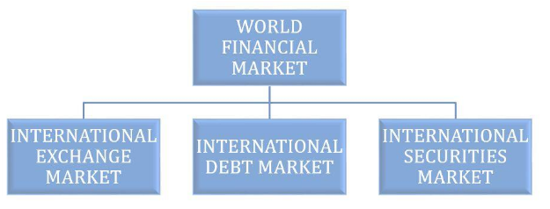
Being a complex system, the financial market has a multilevel structure including 5 market segments:

1. Foreign exchange market (Forex) or Currency market
It is the market in which the subject of its participants interaction is the currency and everything that is related to its equivalent. Derivative instruments may also serve as trading instruments (for example, currency CFDs). Depending on the form, the settlement there can be cash and non-cash; according to the transaction term, the market can be current (spot) and derivatives currency markets. Derivatives market contracts can be:
- Forward contracts. A forward contract is customized between two parties at an agreed price; intermediaries of the transaction are commercial banks, there are no guarantees.
- Futures feature pricing, based according to the movement of currency exchange rates , intermediary is an exchange, guarantees are the reserve deposit.
- Options and currency swaps.
Currency transactions can be performed both on the exchange and on the over-the-counter market (Forex Interbank Market, Forex).

2. Credit market
This market suggests a redistribution of spare funds from those who have them to those who do not have them. Unlike the investment market, the credit market is more complex (it has a three-tier structure) and has tighter requirements for participants to fulfill their obligations.
Credit market Levels:
- The central bank and commercial banks. Here, the central bank acts as a regulator. By means of loans, the central bank regulates the money supply, supports banks, facing temporary troubles, keeps the liquidity of banking system and covers the cash gaps.
- Commercial banks and their clients
- Credit relations between legal entities

3. Insurance market
It is a separate segment, as insurance companies are one of the main investors at the global level. Providing various kinds of insurance services, they accumulate capital, which they can temporarily invest in deposits, metals, and the stock market.

4. Investment market
It is a system based on free competition and partnerships between agents of investment activity. It has much in common with the stock market, where the funds are invested in securities, but it can also take the form of capital investments, fixed assets, etc. Simply put, the investment market provides investing money in any asset for the purpose of subsequent earnings over a period of time due to an increase in an asset price or dividend payments.

5. Stock market: securities
- It suggests a complex interaction between the market participants in terms of issuance and turnover of securities. Securities can be traded on both stock exchanges and beyond them. On the exchanges, you can trade only enlisted assets, i.e. which meet certain requirements. Assets can be:
- Stocks. They can be common stocks and preferred stocks. Holders of common stock typically have voting privileges, whereas holders of preferred stock may not. However, preferred stockholders receive a fixed dividend from the company, while common shareholders may or may not receive one, depending on the decisions of the board of directors.
- Bonds. Bonds can be (issuer - company), municipal (issuer - local authorities), state, international (for example, Eurobonds). Bonds can also be preferential (the holder will be among the first to receive money during the liquidation of the company) and subordinated (more profitable, but riskier). There is a gradation on the coupon rate and yield to maturity.
- Indices - consolidated instruments consisting of a basket of securities, which reflect average price statistics for the sector or for the industry in general.
- Derivatives. They are derived instruments, which make up a multi-level system of securities.
- ETF securities. An ETF is an index fund whose shares (units) are traded on an exchange. The fund's investment structure can be anyone, ranging from securities of companies in a particular sector to a diversified portfolio, including stocks, gold, etc. Unlike shares of investment funds, you can perform any operations with ETF shares, as well as with securities.
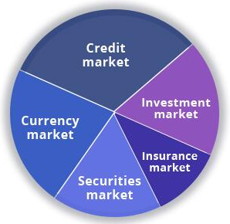

Functions of the financial market
The financial market plays an important role in our modern civilized society. It aims to mobilize capital, distribute it between industries, control and maintain the reproduction process and improve the efficiency of the economic system in general. Main functions of the financial market, carried out by its participants are following:
- Facilitate efficient relationships between all market participants, ranging from private individuals and individual investors, to large institutional investors.
- Supervise and regulate the processes held in the financial system: regulation of the money supply, compliance control for established rules by market participants, licensing, development of legal provisions.
- Mobilize the capital and allocate it so that it is used most efficiently and generates added value
- Minimize risks, including fraud prevention (anti-money-laundering). Ensure transparent pricing and avoiding price manipulation.
- Provide market liquidity
- Ensure privacy and transparency of the transactions made
- Provide necessary information
The activities of the financial market are based on national banks' liabilities to control currency rates and set interest rates. Stock and currency markets, as well as commercial banks, are directly connected with the development of the financial assets market. The securities market is the most interesting segment of the financial market in terms of investment profitability.

Participants of the financial market
Each of us is a financial market participant in a way. Each of us works somewhere, making an own contribution in GDP rate, buys something, so indirectly affecting inflation rate and the level of consumer prices. Someone becomes an investor, buying a foreign currency or collectible coins, or investing in bank deposits, investment companies, using loans.
It suggests that the financial market, in a simplified form, is a relationship between two categories of participants: sellers and buyers. The third category include intermediaries who are directly involved in transactions, providing assistance, facilitation and guarantees. The same agent of the financial market can act simultaneously as the seller, and the buyer, and the intermediary.

1. Currency market:
- Sellers. The major sellers are the state and banks. The state that sells a currency through authorized bodies performs a regulatory function in this way. Sellers are also companies engaged in foreign economic activity (selling foreign-currency earnings) and individuals.
- Buyers. All agents, being sellers, can act as buyers.
- Intermediaries. This category may include commercial

2. Credit market:
- Borrowers. At the international level, borrowers are states and the ratio of external debt to GDP is considered one of the key statistical indicators of the state of the country's economy. At the country level, borrowers are individuals and companies, local governments, etc. A good example of a multi-level structure of the credit market is the US mortgage system, where banks issued securities for mortgages to accumulate new capital for subsequent lending.
- Lenders. These market participants possess spare capitals and wish to increase it: individuals, investing their funds in deposits that will be subsequently directed to lending, buyers of debt securities (insurance, pension, investment funds). In a way, any investor can be called a lender, since he/she gives spare money in order to gain interest rates and invest the income in development. The state can be also referred to as a lender, which creates liquidity and distributes the money to borrowers through the central bank.
- Intermediaries. They are all who participate organization of the money distribution: banks, brokers, dealers, managing investment companies. Insurance and pension funds can be also attributed to intermediaries, accumulating and distributing capital.

3. Insurance market:
- Insurers: These are companies, appropriately licensed to provide insurance services. There are insurance companies of open type (provide services to all market participants), captive insurers (being wholly owned and controlled by its insureds) and reinsurance risk management companies.
- Insurers: Individuals, companies, institutions, buying insurance services to minimize the risks.
- Intermediaries: There are no intermediaries, transactions are carried out directly between the insurer and the insured.
4. Investment market.
Everyone, who invests money in a particular asset, is an investor. The intermediaries can be banks, exchanges, different kinds of funds and so on.

5. Stock market:
- Securities issuers. These include companies and organizations that issue certain securities: stocks, bonds, etc. When issuing, issuers agree that they must fulfill all the requirements specified (agreed) at the time of issue.
- Investors. They are all those who buy securities in order to generate income. There are strategic (buying a majority stake) and minority (making up a portfolio, buying the securities in order to only generate income).
- Intermediaries. Stock exchanges, banks, underwriters, ranking agencies, auditors and other participants, engaged in facilitation for issuance and placement of securities.
The classification, described above, can be grouped in the following way:
- The state and the central banks (regulating and supervising organizations). Managing the biggest volume of the capital, these agents mostly perform supervising and regulation function.

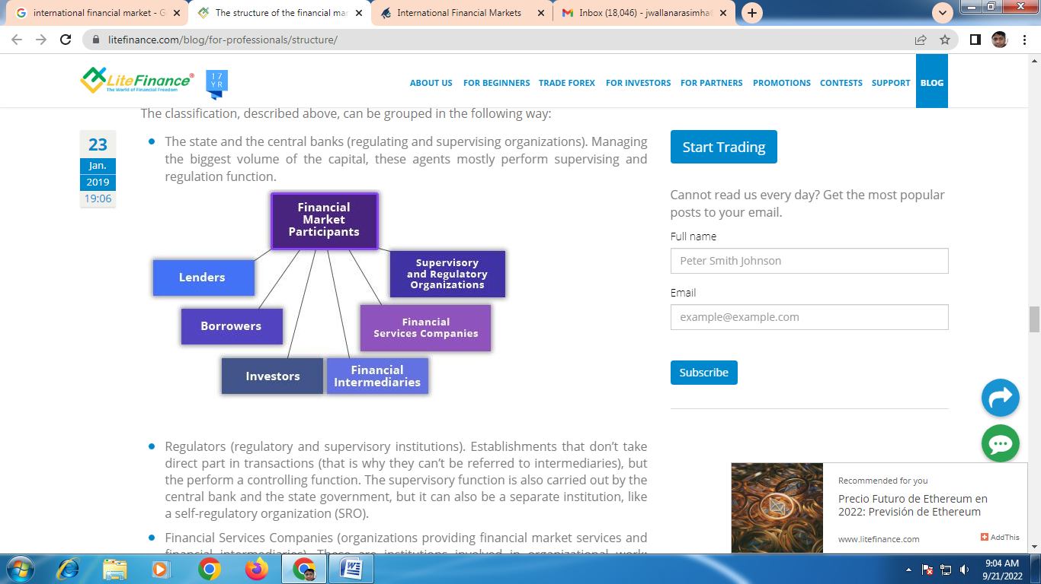
Regulators (regulatory and supervisory institutions). Establishments that don’t take direct part in transactions (that is why they can’t be referred to intermediaries), but the perform a controlling function. The supervisory function is also carried out by the central bank and the state government, but it can also be a separate institution, like a self-regulatory organization (SRO).
- Financial Services Companies (organizations providing financial market services and financial intermediaries). These are institutions involved in organizational work: currency, stock and commodity exchanges, brokers, underwriters, auditors, depositories, registrars, clearing and consulting companies.
- Banks (financial intermediaries). They are intermediaries involved in the capital distribution, market regulation and supervision for the established rules compliance.
- Legal entities (lenders, investors, borrowers). The most extensive group of participants: companies engaged in the placement of clients' pension savings, investment services, insurance companies, hedge funds, trust management companies, brokers, dealers, individual lending organizations, companies engaged in any type of financial activity, participating the in money turnover.
- Individuals (lenders, borrowers, investors): traders, speculators, individual asset managers, long-term investors, and just ordinary people, as it was mentioned at the beginning of the part.]

INTERNATIONAL MONEY MARKET:
The international money market acts as a marketplace for several central banks of different countries that transact primarily in US dollars. As a result, the transactions involve depositing, borrowing, or lending money internationally. Mainly, the purpose of the international money market is to handle the international currencies of different countries. Similarly, the international money market is a safe instrument and offers low returns. The users of the money market are mainly big players like central banks of various countries, big corporations, and financial institutions. Individuals are not a part of the international market like the domestic money market. The common instruments include money market, mutual funds, and treasury bills.
PURPOSE: The purpose of investing in the money market differs from individual to organization. Individuals invest to gain profit, or we can say speculative trading. However, organizations want to invest, rather park their excess cash in a return-bearing instrument. This is the market for the short term and mostly for investing surplus cash. Therefore, the two common characteristics of the money market are safety and low rates of returns.
Some of the major international money market participants are −
- Citigroup
- Barclays Capital
- Bank of America
- JP Morgan Chase
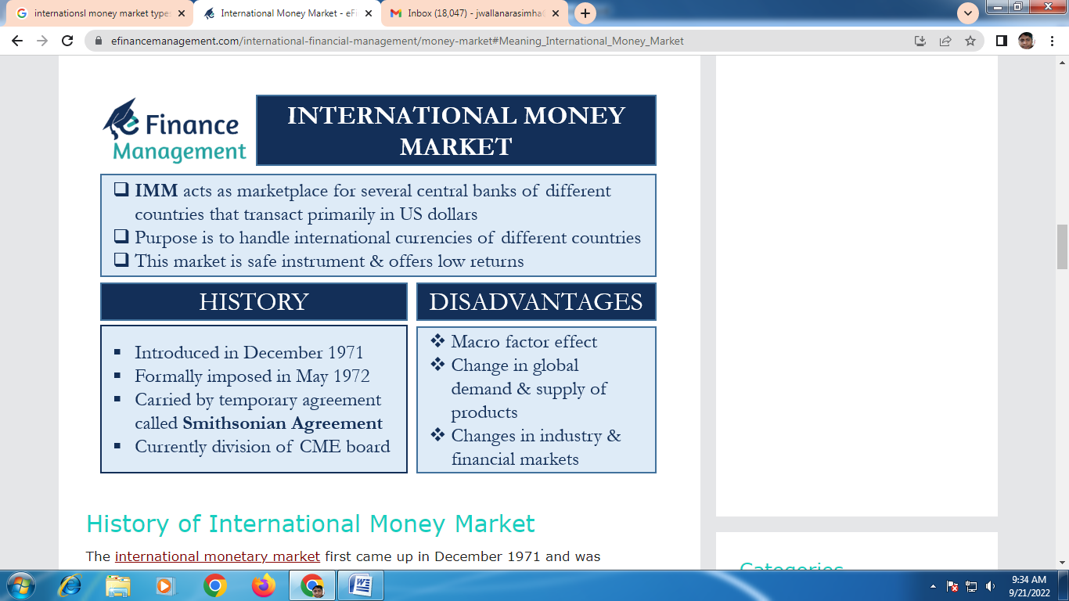

Instruments of Money Market in INDIA

Call Money
- Inter bank market where funds are borrowed and lent for 1 day or less.
- If >1 day and up to 14 days, it is called notice money.
- Mutual funds, scheduled commercial & cooperative banks act as both borrowers and lenders.
- LIC, GIC, NABARD, IDBI act only as lenders.

Treasury Bills
- Issued by RBI on behalf of govt.
- Govt uses them to meet their short-term liquidity crunch.
- T-bills are sovereign zero risk instruments.
- At present, 3 types of T-bills are there : 91-day, 182-day, 364-day.
- State govt can not issue T-bills.
- They are issued by Market Stabilization Scheme (MSS).
- Available for a minimum amount of Rs 25000 or in multiples of that.

Cash Management Bills (CMBs)
- It's a comparatively new short-term instrument issued by RBI on behalf of Govt.
- Issued to meet temporary mismatches in cash flow of Govt.
- They resemble T-bills in character but are issued for less than 91 days only.

Certificate of Deposit (CDs)
- Issued by scheduled commercial banks and other financial institutions.
- RRBs and local area banks can not issue CDs.
- Issued at a discount to face value, the discount rate is negotiated between issuer and investor.
- Minimum amount to be Rs 1 lac.
- CDs issued by banks have a maturity period: 15 days to 1 year.
- CDs issued by selected FIs have maturity period: 1 year to 3 years.
- Can be issued to individuals or firms.

Commercial Paper (CP)
- These are unsecured promissory* notes issued by large corporates, primary dealers, satellite dealers and all India FIs.
- Maturity period is between 7 days up to 1 year from date of issue.
- Minimum amount to be invested is Rs 5 lacs or multiples of that.
- The net worth for a corporate to be able to issue it is 4 crore.
- CPs need to have a credit rating from a credit rating agency.

Commercial Bills (CBs)
- Negotiable instruments which are issued by all India FIs, NBFCs, SCBs, Merchant banks & Mutual funds.
- Drawn by seller on the buyer (buyer gives seller), hence also called trade bills.

Inter Corporate Deposit Market
- This is a market where corporates extend the unsecured loan to each other.
- Majorly used by low rated corporates for managing their funds.

LIBOR
- Developed and launched by British Bankers Association in the 1980s
- It is the average interest rate at which leading banks borrow or lend, estimated in London.
- It reflects market conditions for international funds.
- Approximately $350 trillion funds are tied to LIBOR as per estimates.

MIBOR
- Developed and launched by NSE in 1998.
- It is the weighted average interest rate at which banks/institutions in Mumbai lend in the call money market.

International Money Market Instruments:

Euro-currency Time Deposits
The overwhelming majority of bank deposits in the Euro-currency market take the forms of non negotiable time deposits. Those who want greater liquidity invest in shorter maturities. A very high proportion of Eurodollar time deposits, especially in the inter-bank market, mature in one week or less.

Certificates of Deposit
Some banks are a little reluctant to issue CDs, because they would prefer not to have their paper traded in a secondary market, especially at times when the bank might be seeking additional short term funding. The secondary paper might compete with the primary paper being offered. Other will issue CDs readily if investors prefer them, perhaps paying ¼ percent or ore below their equivalent time deposit rate to reflect the additional liquidity and the somewhat greater documentary inconvenience of CDs.

Bankers Acceptances
Banker’s acceptances are money market instruments arising, typically, from international trade transactions that are financed by banks. The banker’s acceptance (BA) itself represents an obligation be a specific bank to pay a certain amount on a certain date in the future. To simplify a bit, it is a claim of the bank that differs little from other short term claims such as CDs. Indeed BAs, when they are traded in a secondary market, trade at a return that seldom deviates much from comparable CDs issued by the same bank.

- Letters of Credit
Letters of credit (L/C) are documents issued by banks in which the bank promises to pay a certain amount on a certain date, if and only if documents are presented to the bank as specified in the terms of the credit. A letter of credit is generally regarded as a very strong legal commitment on the part of a bank to pay if the conditions of trade documents are fulfilled.

Euro-notes and Euro-commercial Paper
These instruments are short term unsecured promissory notes issued by corporations and banks. Euro-notes, the more general term, encompasses note issuance facilities, those that are underwritten, as well as those that are not underwritten. The term Euro-commercial paper is generally taken to mean notes that are issued without being backed by an underwriting facilities that is, without out the support of a medium term commitment by a group of banks to provide funds in the event that the borrower is unable to roll over its Euro-notes on acceptable terms. The Euro-notes market takes the form of non underwritten Euro-commercial paper (ECP), so the actual paper that an investor will find available for investment is likely to be ECP.

Like US commercial paper, Euro-notes and ECP are traded by conversion on a discount basis, and interest is calculated as “actual/360,” meaning that the price is set as 100 minus the discount interest rate multiplied by the actual number of days to maturity, over 360.

International Capital Markets:
A capital market is basically a system in which people, companies, and governments with an excess of funds transfer those funds to people, companies, and governments that have a shortage of funds. This transfer mechanism provides an efficient way for those who wish to borrow or invest money to do so. For example, every time someone takes out a loan to buy a car or a house, they are accessing the capital markets. Capital markets carry out the desirable economic function of directing capital to productive uses.
There are two main ways that someone accesses the capital markets—either as debt or equity. While there are many forms of each, very simply, debt is money that’s borrowed and must be repaid, and equity is money that is invested in return for a percentage of ownership but is not guaranteed in terms of repayment.
International capital markets are the same mechanism but in the global sphere, in which governments, companies, and people borrow and invest across national boundaries. In addition to the benefits and purposes of a domestic capital market, international capital markets provide the following benefits:
- Higher returns and cheaper borrowing costs. These allow companies and governments to tap into foreign markets and access new sources of funds. Many domestic markets are too small or too costly for companies to borrow in. By using the international capital markets, companies, governments, and even individuals can borrow or invest in other countries for either higher rates of return or lower borrowing costs.
- Diversifying risk. The international capital markets allow individuals, companies, and governments to access more opportunities in different countries to borrow or invest, which in turn reduces risk. The theory is that not all markets will experience contractions at the same time.
Types of ICM:
The structure of the capital markets falls into two components—primary and secondary.
- Primary market :
The primary market is where new securities (stocks and bonds are the most common) are issued. If a corporation or government agency needs funds, it issues (sells) securities to purchasers in the primary market. Big investment banks assist in this issuing process as intermediaries. Since the primary market is limited to issuing only new securities, it is valuable but less important than the secondary market.
Its Types:
- IPO
- PREFERENTIAL ISSUE
- RIGHT ISSUE
- BONUS ISSUE
- UNDERWRITTERS
- Secondary market
The secondary market includes stock exchanges (The New York Stock Exchange, the London Stock Exchange, and the Tokyo Nikkei), bond markets, and futures and options markets, among others. All these secondary markets deal in the trade of securities. The term securities includes a wide range of financial instruments. You’re probably most familiar with stocks and bonds. Investors have essentially two broad categories of securities available to them: equity securities, which represent ownership of a part of a company, and debt securities, which represent a loan from the investor to a company or government entity.

Top 6 stock exchanges in the world:

- New York Stock Exchange
- NASDAQ
- Tokyo Stock Exchange
- Shanghai Stock Exchange
- Hong Kong Stock Exchange
- London Stock Exchange

Major Components of the International Capital Markets:

International Equity Markets
Companies sell their stock in the equity markets. International equity markets consists of all the stock traded outside the issuing company’s home country. Many large global companies seek to take advantage of the global financial centers and issue stock in major markets to support local and regional operations.
The key factors for the increased growth in the international equity markets are the following:
- Growth of developing markets. As developing countries experience growth, their domestic firms seek to expand into global markets and take advantage of cheaper and more flexible financial markets.
- Drive to privatize. In the past two decades, the general trend in developing and emerging markets has been to privatize formerly state-owned enterprises. These entities tend to be large, and when they sell some or all of their shares, it infuses billions of dollars of new equity into local and global markets. Domestic and global investors, eager to participate in the growth of the local economy, buy these shares.
- Investment banks. With the increased opportunities in new emerging markets and the need to simply expand their own businesses, investment banks often lead the way in the expansion of global equity markets. These specialized banks seek to be retained by large companies in developing countries or the governments pursuing privatization to issue and sell the stocks to investors with deep pockets outside the local country.
- Technology advancements. The expansion of technology into global finance has opened new opportunities to investors and companies around the world. Technology and the Internet have provided more efficient and cheaper means of trading stocks and, in some cases, issuing shares by smaller companies.

International Bond Markets
Bonds are the most common form of debt instrument, which is basically a loan from the holder to the issuer of the bond. The international bond market consists of all the bonds sold by an issuing company, government, or entity outside their home country. Companies that do not want to issue more equity shares and dilute the ownership interests of existing shareholders prefer using bonds or debt to raise capital (i.e., money). Companies might access the international bond markets for a variety of reasons, including funding a new production facility or expanding its operations in one or more countries. There are several types of international bonds, which are detailed in the next sections.

Foreign Bond
A foreign bond is a bond sold by a company, government, or entity in another country and issued in the currency of the country in which it is being sold. There are foreign exchange, economic, and political risks associated with foreign bonds, and many sophisticated buyers and issuers of these bonds use complex hedging strategies to reduce the risks. For example, the bonds issued by global companies in Japan denominated in yen are called samurai bonds.

Eurobond
A Eurobond is a bond issued outside the country in whose currency it is denominated. Eurobonds are not regulated by the governments of the countries in which they are sold, and as a result, Eurobonds are the most popular form of international bond. A bond issued by a Japanese company, denominated in US dollars, and sold only in the United Kingdom and France is an example of a Eurobond.

Global Bond
A global bond is a bond that is sold simultaneously in several global financial centers. It is denominated in one currency, usually US dollars or Euros. By offering the bond in several markets at the same time, the company can reduce its issuing costs. This option is usually reserved for higher rated, creditworthy, and typically very large firms.

Eurocurrency Markets
The Eurocurrency markets originated in the 1950s when communist governments in Eastern Europe became concerned that any deposits of their dollars in US banks might be confiscated or blocked for political reasons by the US government. These communist governments addressed their concerns by depositing their dollars into European banks, which were willing to maintain dollar accounts for them. This created what is known as the Eurodollar—US dollars deposited in European banks.
Over the years, banks in other countries, including Japan and Canada, also began to hold US dollar deposits and now Eurodollars are any dollar deposits in a bank outside the United States. (The prefix Euro- is now only a historical reference to its early days). An extension of the Eurodollar is the Eurocurrency, which is a currency on deposit outside its country of issue. While Eurocurrencies can be in any denominations, almost half of world deposits are in the form of Eurodollars.

The Euro loan market is also a growing part of the Eurocurrency market. The Euro loan market is one of the least costly for large, creditworthy borrowers, including governments and large global firms. Euro loans are quoted on the basis of LIBOR, the London Interbank Offer Rate, which is the interest rate at which banks in London charge each other for short-term Eurocurrency loans.

ARBITRAGE:
Arbitrage is the process of simultaneous buying and selling of an asset from different platforms, exchanges or locations to cash in on the price difference (usually small in percentage terms). While getting into an arbitrage trade, the quantity of the underlying asset bought and sold should be the same. Only the price difference is captured as the net pay-off from the trade. The pay-off should be large enough to cover the costs involved in executing the trades (i.e. transaction costs). Else, it won’t make sense for the trader to initiate the trade in the first place.

MEANING: Arbitrage is an investment strategy in which an investor simultaneously buys and sells an asset in different markets to take advantage of a price difference and generate a profit. While price differences are typically small and short-lived, the returns can be impressive when multiplied by a large volume. Arbitrage is commonly leveraged by hedge funds and other sophisticated investors.
Description: Suppose an asset, gold, is quoted at Rs 27,000 per 10 gm in the Delhi bullion market and at Rs 27,500 in the Mumbai bullion market. A trader may buy 10 gm of gold in Delhi and sell it in Mumbai, making a profit of Rs 500 (Rs 27,500 - Rs 27,000). However, this trade will be profitable only if the cost of transactions is less than Rs 500 per 10 gm of gold
There are several types of arbitrage, including pure arbitrage, merger arbitrage, and convertible arbitrage. Global macro is another investment strategy related to arbitrage, but it’s considered a different approach because it refers to investing in economic changes between countries.

Types of Arbitrage
The different kinds of arbitrage practices are as follows:
- Pure Arbitrage: Here, the arbitrageur takes an immediate buy and sell decision without blocking the funds.
- Risk Arbitrage: Often, investors estimate a price rise of the stock and thus block the money by buying and then holding it. Basically, the investors expect a price hike in another market.
- Retail Arbitrage: This is a common practice in e-commerce. Arbitrageurs buy a certain product at a discounted price from the local retailer and then sell it on an e-commerce website for a high price.
- Merger Arbitrage: This is a strategic activity. Arbitrageurs procure the stocks of a target company when they suspect an imminent takeover or merger. When the prices accelerate after the merger, they sell the shares.
- Convertible Arbitrage: Arbitrageurs benefit from holding a long position in convertible security and by grabbing a short position in the underlying stock.
- Dividend Arbitrage: Under this type, traders purchase stocks just before the ex-dividend date. The ex-dividend date is the date by which the investor has to complete his purchase of the underlying stock. Only then is he eligible for the dividend on the the listed date.

Arbitrage Opportunities
Traders generate risk-free profits in two ways. First, they sell at higher prices in one stock exchange. Then, they buy the same security from another stock exchange at lower prices—in real-time. This way, they benefit from the price difference.
Similarly, the traders purchase an asset at a lower price from one stock exchange. Then they sell the same asset at a higher price in another stock exchange. Again, all this is done in real-time to benefit from the price difference.
Arbitrageurs use the following options to generate profits:
- Security or asset – buying and selling of equity, bonds, and other financial instruments over two or more stock exchanges or stock markets;
- Commodity – procuring goods from one nation or market at a reasonable price and then selling it in another nation or market where its market price is high;
- Currency – acquiring a currency pair from one broker at a nominal price and selling it to another at a higher value.
Market integration:
It occurs when prices among different locations or related goods follow similar patterns over a long period of time. Groups of goods often move proportionally to each other and when this relation is very clear among different markets it is said that the markets are integrated. Thus, market integration is an indicator that explains how much different markets are related to each other.
Types of market integration:
1. Horizontal integration
This occurs when a firm or agency gains control of other firms or agencies performing similar marketing functions at the same level in the marketing sequence. In this type of integration, some marketing agencies combine to form a union with a view to reducing their effective number and the extent of actual competition in the market. It is advantageous for the members who join the group.
2. Vertical integration
This occurs when a firm performs more than one activity in the sequence of the marketing process. It is a linking together of two or more functions in the marketing process within a single firm or under a single ownership. This type of integration makes it possible to exercise control over both quality and quantity of the product from the beginning of the production process until the product is ready for the consumer. It reduces the number of middle men in the marketing channel.
a) Forward integration
If a firm assumes another function of marketing which is closer to the consumption function, it is a case of forward integration. Example: wholesaler assuming the function of retailing
b) Backward integration
This involves ownership or a combination of sources of suppl. Example: when a processing firm assumes the function of assembling/purchasing the produce from the villages.
3. Conglomeration
A combination of agencies or activities not directly related to each other may, when it operates under a unified management, be termed a conglomeration.

Depository Receipt
When any foreign company or any foreign individual with the help of Domestic Bank or Depository invests in the Domestic Companies listed in the local stock exchange of that particular country’s currency, the receipt offered to that individual is known as Depository Receipt.

What are ADR (American Depository Receipt) :

ADR (American Depository Receipt) is a negotiable financial instrument which is issued by a US bank representing securities of a foreign company listed on the US stock market. The domestic investors invest in the companies outside their country where the dividend is paid to the ADR holders in US Dollars.
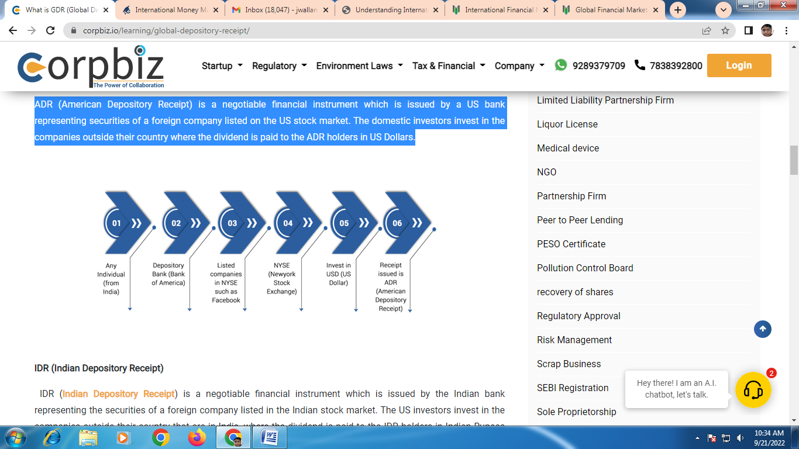
IDR (Indian Depository Receipt)
IDR (Indian Depository Receipt) is a negotiable financial instrument which is issued by the Indian bank representing the securities of a foreign company listed in the Indian stock market. The US investors invest in the companies outside their country that are in India, where the dividend is paid to the IDR holders in Indian Rupees (INR).
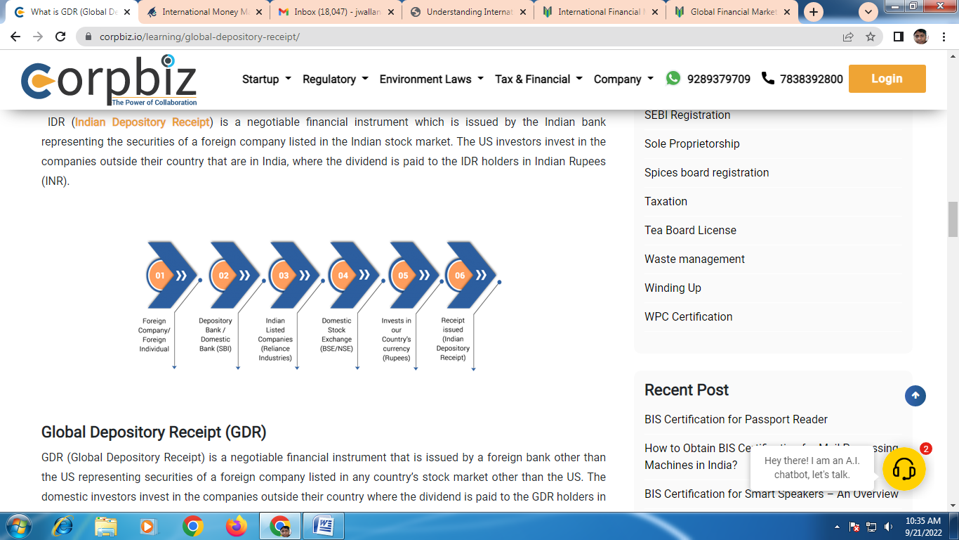

Global Depository Receipt (GDR)
GDR (Global Depository Receipt) is a negotiable financial instrument that is issued by a foreign bank other than the US representing securities of a foreign company listed in any country’s stock market other than the US. The domestic investors invest in the companies outside their country where the dividend is paid to the GDR holders in Euro or GBP.
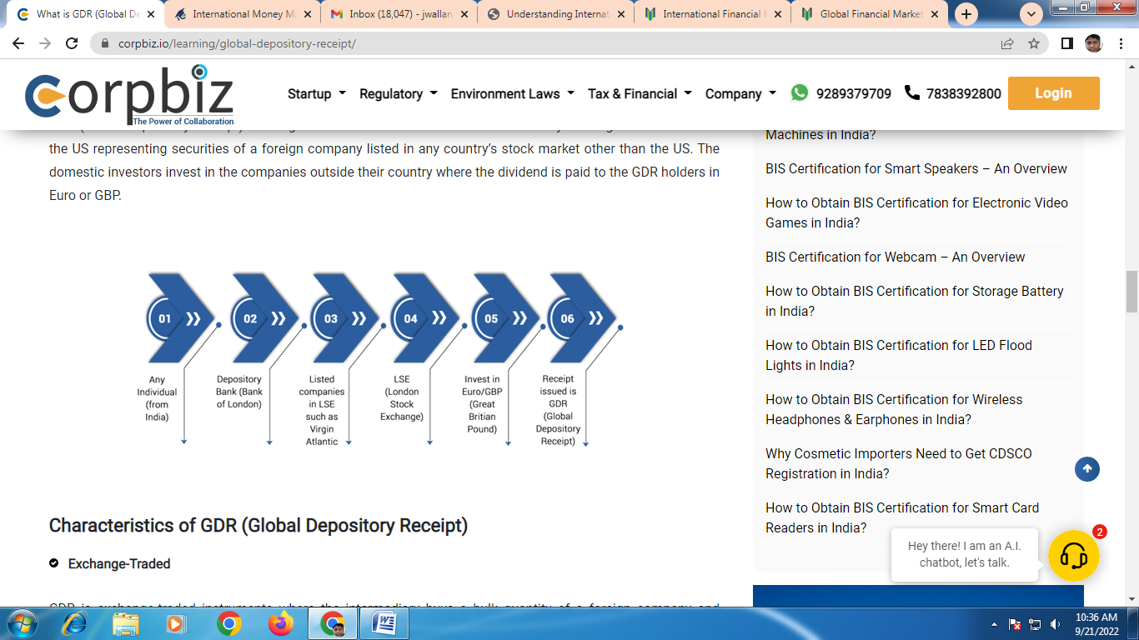

Characteristics of GDR (Global Depository Receipt)
- Exchange-Traded
GDR is exchange-traded instruments where the intermediary buys a bulk quantity of a foreign company and creates the GDRs which are traded on the local stock exchange. These GDRs are then traded on the multiple stock exchanges of multiple countries other than the US.
- Conversion Ratio
Conversion ration means the number of shares a GDR can hold. Usually, it varies from a fraction to a very high number. Although 1 GDR certificate holds ten shares, the range is flexible.
- Unsecured
GDR is unsecured securities and is not backed by any asset other than the value of the shares that are held in that certificate.
- Price Based on Underlying
The price of a GDR is based on the price of the share that it holds, the supply and demand of a particular GDR.
- GDR is denominated in any foreign currency
The fundamental shares shall be denominated in the local currency of the issuer but GDR is always denominated in foreign currency.
- The holder is entitled to dividend and bonus
On the basis of value of shares under the GDR the holder of the same is entitled to bonus and dividend.

Advantages of GDR to Issuing Company
- There is accessibility to foreign capital markets.
- There is an increase in the visibility of the issuing company.
- Rise in the capital of the issuing company because of foreign investors.

Advantages of GDR to Investor
- It provides more transparency since competitors’ securities can be compared.
- There is the capital gain payment.

Disadvantages of Global Depository Receipts
- Violation of any regulation can lead to serious consequences against the company.
- In GDR, the dividends are paid in the Domestic country’s agency, which is subject to volatility in the forex market.
- GDR is an expensive source of financing for any company.
- It is beneficial to the investors who have the capacity to invest a high amount in GDR.

Procedure for the Issuance of GDR in a Company
- Approvals
For the issuance of GDR, you first need the approval of the Board of Directors, Shareholders, Regulatory Authorities, and Financial Institutions.
- Appointment of Intermediaries
After the approval, intermediaries like Lead Manager, Co-Manager, Overseas Depository Banks, Legal Advisors, Auditors, and Underwriters are appointed as Intermediaries during the creation of GDR of the company.
- Documentation
Principal Documents like Subscription agreement, Depository agreement, and Trust deed are made.
- Pre and Post Launch
In the end, additional key actions like timing, pricing the issue, the closing of the issue are done.

Euro bonds

Euro bonds may define as an international bond underwritten by an international syndicate and sold in countries other than the country of the currency in which the issue denominates. In the Eurobond market, the investor holds a claim directly on the borrower rather than on a financial institution.

Eurobonds are generally issued by corporations and governments needing secure, long-term funds and are sold through a geographically diverse group of banks to investors around the world. Eurobonds are similar to domestic bonds in that they may issue with fixed or floating interest rates.

Types of Eurobonds:

There are three types of Eurobonds, of which two are international bonds. A domestic bond is a bond issue in a country by a resident of that country.

There are several different types of Eurobonds.
- Straight Bond: Bond is one having a specified interest coupon and a specified maturity date. Straight bonds may issue with a floating rate of interest. Such bonds may have their interest rate fixed at six-month intervals of a stated margin over the LIBOR for deposits in the currency of the bond. So, in the case of a Eurodollar bond, the interest rate may base upon LIBOR for Eurodollar deposits.
- Convertible Eurobond: The Eurobond is a bond having a specified interest coupon and maturity date. But, it includes an option for the hold to convert its bonds into an equity share of the company at a conversion price set at the time of issue.
- Medium-term Eurobond: Medium-term Euro notes are shorter-term Eurobonds with maturities ranging from three to eight years. Their issuing procedure is less formal than for large bonds. Interest rates on Euro notes can fix or variable. Medium-term Euro-notes are similar to medium-term roll-over Eurodollar credits. The difference is that in the Eurodollar market lenders hold a claim on a bank and not directly on the borrower.
Characteristics of euro bonds :
- Straight bonds: the fixed interest rate at periodic intervals, usually annually.
- Floating-rate notes (FRNs): rollover pricing payment usually six months interest stated in terms of a spread over some reference rate.
- Zero-coupon bonds: discount securities, sold either at a fraction of face value and redeemed at face value, or sold at face value and redeemed at a premium.
- Convertible bonds: can exchange for some other type of asset: stock, gold, oil, other bonds.
- Mortgage-backed Eurobonds: backed by a pool of mortgages, or other bonds Institutions which would otherwise exclude from Eurobond market can get access.
- Dual-currency bonds: purchased in one currency, coupon or principal paid in a second currency.
Features of Eurobonds :
- The issuing technique takes the form of a placing rather than formal issuing, this avoids national regulations on new issues.
- Eurobonds place simultaneously in many countries through syndicates of underwriting banks. Which sells them to their investment clientele throughout the world.
- Unlike foreign bonds, Eurobonds sale in countries other than that of the currency of denomination; thus dollar-denominated Eurobonds sale outside the U.S.A.
- The interest on Eurobonds is not subject to withholding tax.

euro deposit(euro currency deposit)

A euro deposit is a deposit of foreign funds into a bank that operates within the European banking system. These banks function on the consolidated European currency—the euro. When an external investor deposits foreign currency into one of these banks, they are effectively depositing in Euros.
A deposit in a currency foreign to the bank’s domestic currency is a Eurocurrency deposit. Banks take Eurocurrency deposits either in the interbank market or from nonbank depositors to fund their Eurocurrency loans. Although the term Eurocurrency originally referred to foreign-currency deposits held at banks in Western Europe, such deposits anywhere in the world are also called Eurocurrency deposits – for example, US dollars held on deposit outside the United States are Eurodollars.
Eurocurrency deposits are not subject to the banking regulations of the currencies’ home country or commonly of the countries in which the deposits are held. The absence of regulations that effect domestic deposits, such as reserve requirements, deposit insurance and interest-rate restrictions enables banks to take Eurodeposits at rates slightly higher and offer Euroloans at rates somewhat lower than the corresponding rates for domestic deposits and loans.
A Euro-certificate of deposit is a negotiable fixed- or floating-rate interest-bearing certificate of deposit issued by banks in bearer form at par with interest and principal paid in a Eurocurrency and an interest rate pegged to LIBOR, commonly in denominations of $1 million and a maturity of less than six months, and quoted on an add-on basis. Euro-CDs are sold directly by banks to depositors or via brokers. Many banks that are active lenders in the syndicated Euro loan market issue long-term variable-rate CDs with a maturity of up to five years for the funding of their Euro loans.
UNIT-III

Foreign Exchange Market
The market in which foreign currencies are bought and sold. The buyers and sellers include individuals, firms, foreign exchange brokers, commercial banks an the central bank. Like any other market, foreign exchange market is a system in which the transactions are not confined to only one or few foreign currencies. There are a large number of foreign currencies which are traded, converted and exchanged in the foreign exchange market.

Foreign Exchange Management Act, 1999:
- The legal framework for the administration of foreign exchange transactions in India is provided by the Foreign Exchange Management Act, 1999.
- Under the FEMA, which came into force with effect from 1st June 2000, all transactions involving foreign exchange have been classified either as capital or current account transactions.
  - Current Account Transactions:
    - All transactions undertaken by a resident that do not alter his / her assets or liabilities, including contingent liabilities, outside India are current account transactions.
      - Example: payment in connection with foreign trade, expenses in connection with foreign travel, education etc.
  - Capital Account Transactions:
    - It includes those transactions which are undertaken by a resident of India such that his/her assets or liabilities outside India are altered (either increased or decreased).
      - Example: investment in foreign securities, acquisition of immovable property outside India etc.
- Resident Indians:
  - A 'person resident in India' is defined in Section 2(v) of FEMA, 1999 as:
    - Barring few exceptions, a person residing in India for more than 182 days during the course of the preceding financial year.
    - Any person or body corporate registered or incorporated in India.
    - An office, branch or agency in India owned or controlled by a person resident outside India.
    - An office, branch or agency outside India owned or controlled by a person resident in India.

Characteristics of foreign exchange market
- Electronic market
- Geographical Dispersal
- Transfer of purchasing power
- Intermediary Volume
- Provision of credit
- Minimizing Risk.

Functions of Foreign Exchange Market
Foreign exchange market performs the following three functions

- Transfer Function-The basic function of the foreign exchange market is to facilitate the conversion of one currency into another, i.e., to accomplish transfers of purchasing power between two countries. This transfer of purchasing power is affected hrough a variety of creditins truments, such as telegraphic transfers, bank draft and foreign bills. In performing the transfer function, the foreign exchange market carries out payments internationally by clearing debts in both directions simultaneously, analogous to domestic clearings.
- Credit Function - It provides credit for foreign trade. Bills of exchange, with maturity period of three months, are generally used for international payments. Credit is required for this period in order to enable the importer to take possession of goods, sell them and obtain money to pay off the bill.
- Hedging Function - Hedging means the avoidance of a foreign exchange risk. In a free exchange market when exchange rate, i. e., the price of one currency in terms of another currency, change, there may be again or loss to the party concerned. Under this condition, a person or a firm undertakes a great exchange risk if there are huge amounts of net claims or net liabilities which are to be met inforeign money. Exchange risk as such should be avoided or reduced.
- Minimizing Foreign Exchange Risk - The foreign exchange market is part of the money market in the financial centers. It is a place where foreign moneys are bought and sold. The buyers and sellers of claim on foreign money and the intermediaries together constitute a foreign exchange market. It is not restricted to any given country or a geographical area. Thus, the foreign exchange market isthe market for a national currency (foreign money) anywhere in the world, as the financial centers of the world are united in a single market. There is a wide variety of dealers in the foreign exchange market. The most important among them are the banks. Banks dealing in foreign exchange have branches with substantial balances in different countries. Through their branches and correspondents, the services of such banks, usually called―Exchange Banks, are available all over the world.

Significance of Forex Management

Forex is also a market where currencies of different countries are bought and sold. This is world market which opens 24 hours. Different business organisation can buy cheap loan and sell it at high prices due to forex market

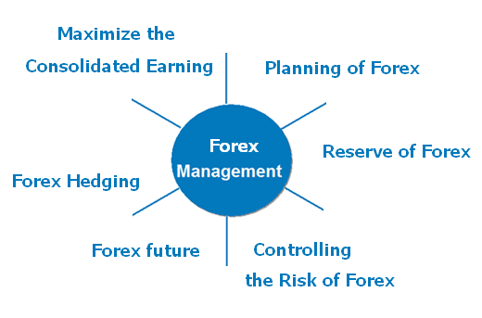

Features of Foreign Exchange Market
This kind of exchange market does have characteristics of its own, which are required to be identified. The features of the Foreign Exchange Market are as follows:
- High Liquidity
The foreign exchange market is the most easily liquefiable financial market in the whole world. This involves the trading of various currencies worldwide. The traders in this market are free to buy or sell the currencies anytime as per their own choice.

- Market Transparency
There is much clarity in this market. The traders in the foreign exchange market have full access to all market data and information. This will help to monitor different countries’ currency price fluctuations through the real-time portfolio.
- Dynamic Market
The foreign exchange market is a dynamic market structure. In these markets, the currency values change every second and hour.
- Operates 24 Hours
The Foreign exchange markets function 24 hours a day. This provides the traders the possibility to trade at any time.

Structure oftheForeignExchangeMarket
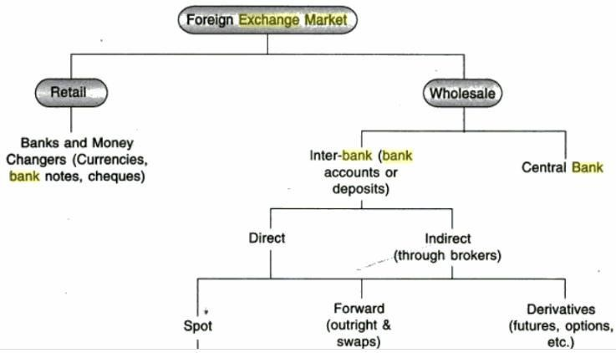

The forex markets tructure comprises;
- Retail Market - Transactions are exchange of currency, bank draft, bank notes ordinary and traveler‘s cheques etc. Retail banking consists of a large number of small customers who consume personal banking and small business services. Retail banking is largely in tra-bank: the bank it self.
- Whole sale markets-The wholesale market comprises of commercial banks and investment banks. This is broadly classified as inter-bank market and central bank market. Wholesale banking typically involves a small number of very large customers such as large corporate and governments, Wholesale banking is largely inter bank: banks use the inter -bank markets to borrow from or lend to other banks, to participate in large bond issues, and to engage in syndicated l ending.
  - Inter-bank - The interbank network consists of a global network of financial institutions that trade currencies between each other to manage exchange rate and interest rate risk. The largest participants in this network are private banks. Most transactions within the interbank network are for a short duration, any where between overnight to six months. The inter bank market is not regulated.
  - Spot market - Spot market refers to the transactions involving sale and purchase of currencies for immediate delivery. In practice, It may take one or two days to settle transactions. Transactions are affected at prevailing rate of exchange at that point of time and delivery of foreign exchange is affected instantly. The exchange rate that prevails in the spot market for foreign exchange is called Spot Rate.
  - Forward Market - A market in which foreign exchange is bought and sold for future delivery is known as Forward Market. It deals with transactions (sale and purchase of foreign exchange)which are contracted today but implemented sometimes in future. Exchange rate that prevails in a forward contract for purchase or sale of foreign exchange is called Forward Rate. Thus, forward rate is the rate at which a future contract for foreign currency is made.
  - Derivatives - Within the fields of trading and finance, a derivative is considered to be an instrument used for investment via a contract. Its value is"derived" from (or based upon) that of another asset, typically referred to as the underlying asset or simply "the underlying." In other words, a derivative contract is an agreement that allows for the possibility to purchase or sell some other type of financial instrument or non-financial asset. Common types of derivative contracts include options ,forwards, futures and swaps.
    - Future Market: Standardized forward contracts are called futures contracts and traded onafuturesexchange.Afuturescontract(morecolloquially,futures)isastandardizedcontractbetween two parties to buy or sell a specified asset of standardized quantity and quality for a price agreed upon today (the futures price or strike price) with delivery and payment occurring at a specified future date.
    - Option Market: A currency option gives an investor the right, but not the obligation, to buy or sell a quantity of currency at a pre-established price on or before the date that the optionexpires.Therighttosellacurrencyisknownasa"calloption"andtherighttobuyisknownas a "put option." Options can be understood as a type of insurance where buyers or sellers can take advantage of more favourable prices should market conditions change after the option is purchased.
    - Swap Market: The idea of a swap by definition normally refers to a simple exchange of property or assets between parties. A currencys wap also involves the conditions determining the relative value of the assets involved. That includes the exchange rate valueofeachcurrencyandtheinterestrateenvironmentofthecountriesthathaveissuedthem.Aforeign exchange swap, forex swap, or FX swap is a simultaneous purchase and sale of identical amounts of one currency for another with two different value dates (normally spot to forward).

The Central Bank
National central banks play an important role in the foreign exchange markets. They try to control the money supply, inflation, and/or interest rates and often have official or unofficial target rates for their currencies. They can use their often substantial foreign exchange reserves to stabilize the market. They work as the lender of the last resort and the custodian of foreign exchange of the country.

The commercial banks are the second most important organ of the foreign exchange market. The banks dealing in foreign exchange play a role of―marketmakers‖, in these nse that they quote on a daily basis the foreign exchange rates for buying and selling of the foreign currencies. Also, they function as clearinghouses, thereby helping in wiping out the difference between the demand for and the supply of currencies. These banks buy the currencies from the brokers and sell it to thebuyers.

The foreign exchange brokers function as a link between the central bank and the commercial banks and also between the actual buyers and commercial banks. They are the major source of market in formation. These are the persons who do not them selves buy the foreign currency, but rather strike a deal between the buyer and the seller on a commission basis.

Market participates of foreign exchange Market
The foreign exchange market assists international trade and investment by enabling currency conversion. The Market Participants are discussed in brief below:
- Commercial Bank - Is a type of financial institution and intermediary. It is a bank that lends money and provides transactional, savings, and money market accounts and that accepts time deposit n ordertofacilitateinternationaltradeanddevelopment,commercialbanksconvertandtradeforeigncurrencies. When a company is doing business in another r country it may be paid in the currency of that country.
- Central bank - National central banks play an important role in the foreign exchange markets. They try to control the money supply, inflation, and/or interest rates and often have official or unofficial target rates for their currencies. They can use their often substantial foreign exchange reserves to stabilize the market.

- Hedge funds asspeculators-About70%to90%oftheforeignexchangetransactionsarespeculative.In other words, the person or institution that bought or sold the currency has no plan to actually take delivery of the currency in the end rather, they were solely speculating on the movement of that particular currency. Hedge funds have gained a reputation for aggressive currency speculation since the 1990s. They control billions of dollars of equity and may borrow billions more, and thus may over whelm intervention by central banks to support almost any currency, if the economic fundamentals are in the hedge funds' favor.

- Investment management firms - Investment management is the professional management of various securities (shares, bonds and other securities) and assets (e.g., real estate) in order to meet specified investment goals for the benefit of the investors. These firms(who typically manage large accounts on behalf of customers such as pension funds and endowments) use the foreign exchange market to facilitate transactions in foreign securities

- Retail foreign exchange traders - One of the most important tools required to perform a foreign exchange transaction is the trading platform providing retail traders and brokers with accurate currency quotes. Retail foreign exchange trading is a small segment of the large foreign exchange market.

ARBITRAGE:
It is the process of a simultaneous sale and purchase of currencies in two or more foreign exchange markets with an objective to make profits by capitalizing on the exchange-rate differentials in various markets.
Arbitrage in trading is the practice of simultaneously buying and selling an asset to take advantage of a difference in price. The asset will usually be sold in a different market, different form or with a different financial product, depending on how the discrepancy in the price occurs.
Opportunities for arbitrage can occur across almost any financial instrument, including options, shares, forex, commodities or derivatives.
Three ways to use the currency arbitrage strategy.
- The First strategy, also called a triangular arbitrage, involves opening positions with 3 currency pairs. For example, a trader can open 3 positions with USD, EUR, and GBP:
Ex: As we can see from the table above, an individual starts with buying 10,000 Euros for 11,000 USD. The second position involves selling the same amount of EUR for 8,800 Pounds. Finally, the trader opens a third trade, where he or she sells the same amount of British currency for $11,044. So an individual has earned $44 from this process which is called triangular arbitrage.

- The second method lets traders exploit the interest rate differentials between different currencies. For example, an investor based in the US might decide to convert his or her US dollars to the higher-yielding currency and invest in that country. At the same time, in order to cover the exchange rate risk an individual might purchase a forward or options contract. This lets an investor lock in the exchange rate when the term of those investments expires and the amounts will be converted back into US dollars.

- Finally, traders can make use of the statistical Forex arbitrage. This might sound complicated but this can be simpler than it seems. It essentially involves buying the underperforming or undervalued currencies against its over performing or overvalued peers and consequently benefiting from the market corrections.

Forex Arbitrage
Forex arbitrage is defined as "the simultaneous purchase and sale of the same, or essentially similar, security in two different markets for advantageously different prices," according to the concept formalised by economists Sharpe and Alexander in the 1990s.
Given the popularity of forex trading, arbitrage strategies are implemented by thousands of participants around the world. Accordingly, someone who practices arbitrage is known as an "arbitrageur." Simply put, an arbitrageur buys cheaper assets and sells more expensive assets simultaneously to take a profit with no net cash flow. In theory, the practice of arbitrage should require no capital and involve no risk. In reality, attempts at arbitrage generally involve both.

Currency arbitrage:
Currency arbitrage exists not because of the movements in the currency rates but due to the differences in quotes. Currency traders usually go for a two-currency arbitrage, like the one in the example. There is also a three-currency arbitrage, but it is infrequent.
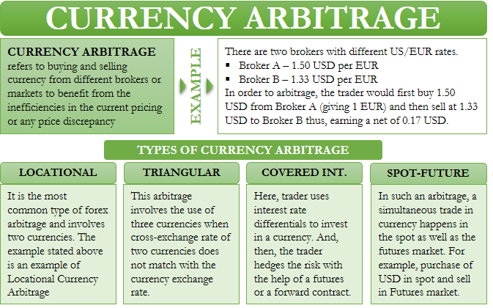

Types of Currency Arbitrage
Following are the common types of forex arbitrage:

Locational Arbitrage
Locational arbitrage is the most common type of forex arbitrage and involves two currencies. We have already given an example of this type of arbitrage above. Let us take another example, but this time with a Bid/Ask spread

Triangular Arbitrage
As the name suggests, this arbitrage involves the use of three currencies. Such a type of arbitrage exists if the cross-exchange rate of two currencies does not match with the currency exchange rate.

Covered Interest Arbitrage
Under covered interest arbitrage, a trader uses interest rate differentials to invest in a currency. And then, the trader hedges the risk with the help of a futures or a forward contract.
- Uncovered interest rate arbitrage also exists.:
It is the same as covering one, but it does not have a futures or forward contract. In this type of arbitrage opportunity, the conversion happens between a local currency with a lower interest rate to other currencies with a higher interest rate.

Spot-future Arbitrage
In such an arbitrage, a simultaneous trade in currency happens in the spot as well as in the futures market. For example, you purchase USD in the spot market and then sell the same in the futures market to make a profit if there is any irregularity in pricing.

Arbitrage calculator
An arbitrage calculator, or arb calculator for short, calculates what the theoretical price of an asset should be based on other inputs and how much you should stake on a trade to guarantee profit.

For example, a triangular arbitrage calculator requires the prices from two currency pairs to calculate the fair price of the third. If the real market price is different, the trader can decide if this is a tradable arbitrage opportunity.

While an arbitrage calculator likely has some sophisticated programming behind it, traders are cautioned to understand the math behind the calculation. For example, if the calculator is rounding, this could eliminate or increase the amount of arbitrage. Therefore, consider double-checking the math before relying on third-party calculations.

How to do arbitrage trading:
- Compare the asset’s market price to the projected or historical price/tendency, or possibly to other comparable assets.
- Calculate the potential profit from the arbitrage trade.
- Deduct fees and transaction costs. Consider spreads, commissions, and interest costs.
- Consider the risks and employ a suitable risk management strategy​ to help your trade.
- Double check the maths and plan how the trades will be executed. Write it down, then ideally have all the orders ready to execute at the same time, if possible.

Mechanics of making foreign payments ( Payment method in international trade)
There are 5 types of payment methods available in international trade.
  - Cash-in-advance
  - Open account
  - Documentary collections
  - Documentary credits (letters of credit)
  - Bank payment obligation.

- Cash-in-Advance: Cash in advance is a payment method in international trade in which an order is not processed until full payment is received by the supplier in advance.Sometimes cash in advance is called cash with order.Cash in advance posses highest risk to the importer, lowest risk to the exporter.
- Open Account: Open account means that buyers pay the cost of the goods after goods have been shipped by the supplier. In an international trade transaction open account defines as a sale where the goods are shipped and/or delivered before payment is due, which is usually in 30 or 60 days. Open account posses highest risk to the exporter, lowest risk to the importer.
- Documentary Collections: International trade procedure in which a bank in the importer’s country acts on behalf of an exporter for collecting and remitting payment for a shipment. The exporter presents the shipping and collection documents to his or her bank (in own country) which sends them to its correspondent bank in the importer’s country.
The foreign bank (called the presenting bank) hands over shipping and title documents (required for taking delivery of the shipment) to the importer in exchange for
- Cash payment (in case of ‘documents against payment‘ instructions) or
- A firm commitment to pay on a fixed date (in case of ‘documents against acceptance‘ instructions).
A documentary collection (D/C) is a transaction whereby the exporter entrusts the collection of a payment to the remitting bank (exporter’s bank), which sends documents to a collecting bank (importer’s bank), along with instructions for payment.
- Documentary Credits: Documentary credits, also known as letters of credit, are one of the payment methods in international trade.
- Letter of credit: It is defined by International Chamber of Commerce publication of UCP 600 as “any arrangement, however named or described, that is irrevocable and thereby constitutes a definite undertaking of the issuing bank to honour a complying presentation.”
- Bank Payment Obligation: Bank payment obligation is a new payment method in international trade.Bank payment obligation (BPO) is an irrevocable undertaking given by an Obligor Bank (typically buyer’s bank) to a Recipient Bank (usually seller’s bank) to pay a specified amount on a agreed date under the condition of successful electronic matching of data according to an industry-wide set of rules adopted by ICC.
Key Points of Consideration When Choosing an International Payment Method
- Financial Needs of the Parties: Open account payment term is a credit granted by the exporter in favor of the importer. In contrast, cash in advance is a credit granted by the importer in favor of the exporter. Letters of credit available by deferred payment and documentary collections payable with time drafts are also financial credits supplied to the buyers. For these reasons financial needs of the parties is a key element determining the payment terms in international trade transactions.
- Negotiation Power of the Parties: Sometimes exporters are in pressure to sell their products. On the other hand, importers are desperate to find a particular good in a short period of time. If balance of the trade power diminishes in favor of one party, then the stronger party may want to benefit from the situation and dictates most favorable payments terms.
- Country Risk of the Exporter and the Importer: As an example if the importer residents in a developed country whereas the exporter sits in a risky country, then the importer may do not want to take risks and choose the most secure payment method for himself.
- Sector of the Transaction Parties: Occupying sector of the exporter and the importer is one of the most influencing element that effects the determination of the payment method. For example, food and textile sector practicing open account payments or documentary collections, on contrary oil sector uses letters of credit.
- Willingness to Take Risks of the Parties: Willingness to take risks is one of the key factor determining the payment method in international trade. Occasionally exporters want to take extra risk, while importers tend to trust their suppliers. A risk taking exporter may ship the goods against open account terms whereas a risk taking importer may decide to pay in advance.
- Legal Legislation: If you want to export to Algeria, you have to choose either documentary collections or letters of credit as a payment method. This is an Algerian legislation and every exporter that makes business with Algeria has to obey this rule.

International Payments (BOP)

International payments, also known as cross border payments or global payments are transactions that involve more than just banks. They connect companies, individuals, banks, and settlement institutions operating in at least two different countries with different currencies that need to be paid

Balance of Payments
The balance of payments (BOP), also known as balance of international payments, summarizes all transactions that a country’s individuals, companies, and government bodies complete with individuals, companies, and government bodies outside the country. These transactions consist of imports and exports of goods, services, and capital, as well as transfer payments, such as foreign aid and remittances.
A country’s balance of payments and its net international investment position together constitute its international accounts.
The sum of all transactions recorded in the balance of payments must be zero, as long as the capital account is defined broadly. The reason is that every credit appearing in the current account has a corresponding debit in the capital account, and vice-versa. If a country exports an item (a current account transaction), it effectively imports foreign capital when that item is paid for (a capital account transaction).
If a country cannot fund its imports through exports of capital, it must do so by running down its reserves. This situation is often referred to as a balance of payments deficit, using the narrow definition of the capital account that excludes central bank reserves.

Balance of Payments is made up of 3 components.
- Current Account – Deals with inflow and outflow of goods and services between countries.
- Capital Account – Deals with foreign exchange reserves, investments, loans & borrowings.
- Financial Account – Deals with investments in real estates, business ventures, Foreign Direct Investments (FDI).

Importance:
- It helps the Government to analyse a particular industry and formulate policies accordingly.
- Helps the Government to detect the state of the economy and accordingly plan the monetary policy, fiscal policies.
- It helps the government to evaluate the tax rates for exports and imports.

UNIT-IV
FOREIGN EXCHANG RATES
Foreign Exchange Rate is defined as the price of the domestic currency with respect to another currency. The purpose of foreign exchange is to compare one currency with another for showing their relative values.
Foreign exchange rate can also be said to be the rate at which one currency is exchanged with another or it can be said as the price of one currency that is stated in terms of another currency.
Exchange rates of a currency can be either fixed or floating. Fixed exchange rate is determined by the central bank of the country while the floating rate is determined by the dynamics of market demand and supply.

Factors Affecting the Exchange Rate
Exchange rate is impacted by some factors which can be economic, political or psychological as well. The economic factors that are known to cause variation in foreign exchange rates are inflation, trade balances, government policies.
Political factors that can cause a change in the foreign exchange rate are political unrest or instability in the country and any kind of political conflict.
Psychological factors that impact the forex rate is the psychology of the participants involved in foreign exchange.

Types of Exchange Rate Systems
There are three types of exchange rate systems that are in effect in the foreign exchange market and these are as follows:
1. Fixed exchange rate System or Pegged exchange rate system: The pegged exchange rate or the fixed exchange rate system is referred to as the system where the weaker currency of the two currencies in question is pegged or tied to the stronger currency.
Fixed exchange rate is determined by the government of the country or central bank and is not dependent on market forces.
To maintain the stability in the currency rate, there is purchasing of foreign exchange by the central bank or government when the rate of foreign currency increases and selling foreign currency when the rates fall.
This process is known as pegging and that’s why the fixed exchange rate system is also referred to as the pegged exchange rate system.
Advantages of Fixed Exchange Rate System
Following are some of the advantages of fixed exchange rate system
- It ensures stability in foreign exchange that encourages foreign trade.
- There is a stability in the value of currency which protects it from market fluctuations.
- It promotes foreign investment for the country.
- It helps in maintaining stable inflation rates in an economy.
Disadvantages of Fixed Exchange Rate System
Following are some of the disadvantages of the fixed exchange rate system
1. There is a constant need for maintaining foreign reserves in order to stabilise the economy.
2. The government may lack the flexibility that is required to bounce back in case an economic shock engulfs the economy.
2. Flexible Exchange Rate System: Flexible exchange rate system is also known as the floating exchange rate system as it is dependent on the market forces of supply and demand. There is no intervention of the central banks or the government in the floating exchange rate system.
Advantages of Floating Exchange Rate System
Following are the advantages of the floating exchange rate system
1. There is no need to maintain foreign reserves in this exchange system.
2. Any deficiencies or surplus in Balance of Payment is automatically corrected in this system.
Disadvantages of Floating Exchange Rate System
Following are some of the disadvantages of the floating exchange rate system
1. It encourages speculation that may lead to fluctuations in the exchange rate of currencies in the market.
2. If the fluctuations in exchange rates are too much it can cause issues with movement of capital between countries and also impact foreign trade.
3. It will discourage any type of international trade and foreign investment.
3. Managed floating exchange rate system: Managed floating exchange rate system is the combination of the fixed (managed) and floating exchange rate systems. Under this system the central banks intervene or participate in the purchase or selling of the foreign currencies.

DETERMINANTS OF FOREIGN EXCHANGE RATES
Foreign exchange (FX) rate is the price of one country’s currency in terms of another country’s currency. Foreign exchange rates are relative and are expressed as the value of one currency compared to another. When selling products internationally, the exchange rate for the two trading countries’ currencies is an important factor. Foreign exchange rates, in fact, are one of the most important determinants of a country’s relative level of economic health, ranking just after interest rates and inflation. Exchange rates play a vital role in a country’s level of trade, which is critical to almost every free market economy in the world. Consequently, exchange rates are among the most watched, analyzed, and manipulated economic measures.
Factors:
International parity conditions: Relative purchasing power parity, interest rate parity, domestic Fisher effect, international Fisher effect: Though to some extent the above theories provide logical explanation for the fluctuations in exchange rates, yet these theories falter as they are based on questionable assumptions (e.g., free flow of goods, services and capital) which seldom hold true in the real world.
Balance of payments model: This model, however, focuses largely on tradable goods and services, ignoring the increasing role of global capital flows. It failed to provide any explanation for the continuous appreciation of the dollar during the 1980s and most part of the 1990s in face of soaring US’ current account deficit.
Asset market model: It views currencies as an important asset class for constructing investment portfolios. Assets’ prices are influenced mostly by people’s willingness to hold the existing quantities of assets, which in turn depends on their expectations on the future worth of these assets. The asset market model of exchange rate determination states that “the exchange rate between two currencies represents the price that just balances the relative supplies of, and demand for, assets denominated in those currencies.”
None of the models developed so far succeed to explain exchange rates and volatility in the longer time frames. For shorter time frames (less than a few days) algorithms can be devised to predict prices. It is understood from the above models that many macro-economic factors affect the exchange rates and in the end the currency prices are a result of the dual forces of demand and supply. The world’s currency markets can be viewed as a huge melting pot: In a large and ever-changing mix of current events, supply and demand factors are constantly shifting, and the price of one currency in relation to another shifts accordingly. No other market encompasses as much of what is going on in the world at any given time as foreign exchange.
These elements generally fall into three categories: economic factors, political conditions and market psychology.
Economic Factors
(a) Economic policy disseminated by government agencies and central banks.
(b) Economic conditions generally revealed through economic reports, and other economic indicators.
- Economic policy: It comprises government fiscal policy (budget/spending practices) and monetary policy (the means by which a government’s central bank influences the supply and ‘cost’ of money, which is reflected by the level of interest rates).
- Government budget deficits or surpluses: The market usually reacts negatively to widening government budget deficits, and positively to narrowing budget deficits. The impact is reflected in the value of a country’s currency.
- Balance of trade levels and trends: The trade flow between various countries illustrates the demand for goods and services, which in turn indicates the demand for a country’s currency to conduct trade. Surpluses and deficits in trade of goods and services reflect the competitiveness of a nation’s economy.
- Inflation levels and trends: Typically a currency will lose value if there is a high level of inflation in the country or if inflation levels are perceived to be rising. This is because inflation erodes purchasing power, thus demand, for that particular currency. However, a currency may sometimes strengthen when inflation rises because of expectations that the central bank will raise short-term interest rates to combat rising inflation.
- Economic growth and health: Reports such as GDP, employment levels, retail sales, capacity utilisation and others detail the levels of a country’s economic growth and health. Generally, the more healthy and robust a country’s economy, the better its currency will perform, thereby leading to more demand.
- Productivity of an economy: Increasing productivity in an economy should positively influence the value of its currency. Its effects are more prominent if the increase is in the traded sector.
Political Factors
Internal, regional, and international political conditions and events can have a profound effect on currency markets. All exchange rates are susceptible to political instability and anticipations about the new ruling party. Political upheaval and instability can have a negative impact on a nation’s economy.
For example, destabilization of coalition governments in Pakistan and Thailand can negatively affect the value of their currencies. Similarly, in a country experiencing financial difficulties, the rise of a political party that is perceived to be fiscally responsible can have the opposite effect. Also, events in one country in a region may spur positive/negative interest in a neighboring country and, in the process, affect its currency.
Market Psychology: Market psychology and trader perceptions influence the foreign exchange market in a variety of ways:
- Flights to quality: Unsettling international events can lead to a ‘flight-to-quality’, a type of capital flight whereby investors move their assets to a perceived ‘safe haven’. There will be a greater demand, and thus a higher price, for currencies perceived as stronger over their relatively weaker counterparts. The US dollar, Swiss franc and gold have been traditional safe havens during times of political or economic uncertainty.
- Long-term trends: Currency markets often move in visible long-term trends. Although currencies do not have an annual growing season like physical commodities, business cycles do make themselves felt. Cycle analysis looks at longer-term price trends that may rise from economic or political trends.
- Economic numbers: While economic numbers can certainly reflect economic policy, some reports and numbers take on a talisman-like effect: The number itself becomes important to market psychology and may have an immediate impact on short-term market moves. ‘What to watch’ can change over time. In recent years, for example, money supply, employment, trade balance figures, and inflation numbers have all taken turns in the spotlight.
- Technical trading considerations: As in other markets, the accumulated price movements in a currency pair such as EUR/USD can form apparent patterns that traders may attempt to use. Many traders study price charts in order to identify such patterns. After understanding the evolution of currencies, market size, liquidity and participants in the last few articles, we will move on to speculation, risk, carry trade and forex signals in the next article.

Derivatives:
Derivatives are securities whose value is determined by an underlying asset on which it is based. Therefore the underlying asset determines the price and if the price of the asset changes, the derivative changes along with it. A few examples of derivatives are futures, forwards, options and swaps. The purpose of these securities is to give producers and manufacturers the possibility to hedge risks. By using derivatives both parties agree on a sale at a specified price at a later date. In each derivative certain aspects are documented such as the relation between the derivative, type of underlying asset and the market in which they are traded. It is essential to understand the strengths and weaknesses of each derivative to employ them to their fullest potential.
1. Futures
Futures are exchange organized contracts which determine the size, delivery time and price of a commodity. Futures can easily be traded because they are standardized by an exchange. Per commodity traded there are different aspects specified in a futures contract. First of all is the quality of a commodity. For a commodity to be traded on the exchange, it must meet the set requirements. Second is the size of a single contract. The size determines the units of a commodity that is traded per contract. Thirdly is the delivery date, which determines on which date or in which month the commodity must be delivered. Thanks to the standardization of futures commodities can easily be traded and give manufacturers access to large amounts of raw materials. They can buy their materials on the exchange and don’t need to worry about the producer or take on contracts with multiple suppliers.
2. Forwards
Forwards and futures are very similar as they are contracts which give access to a commodity at a determined price and time somewhere in the future. A forward distinguish itself from a future that it is traded between two parties directly without using an exchange. The absence of the exchange results in negotiable terms on delivery, size and price of the contract. In contrary to futures, forwards are usually executed on maturity because they are mostly use as insurance against adverse price movement and actual delivery of the commodity takes place. Whereas futures are widely employed by speculators who hope to gain profit by selling the contracts at a higher price and futures are therefore closed prior to maturity.
3. Swaps
A swap is an agreement between two parties to exchange cash flows on a determined date or in many cases multiple dates. Typically, one party agrees to pay a fixed rate while the other party pays a floating rate. For example, when trading commodities the first party, an airline company relying of kerosene, agrees to pay a fixed price for a pre-determined quantity of this commodity. The other party, a bank, agrees to pay the sport price for the commodity. Hereby the airline company is insured of a price it will pay for its commodity. A rise in the price of the commodity is in this case paid by the bank. Should the price fall the difference will be paid to the bank.

Option
There are two types of options. A call option gives the holder the right to purchase an asset at an agreed-upon price on or before a specified date. This agreed-upon price is known as the exercise price. It has to be noted that the holder has the option and can choose to not buy the asset.
The purchase price of the option is called the premium. It represents the compensation the purchaser of the call option must pay for the right (but not the obligation) to exercise the option.
It will make sense for the call option holder to exercise his option only if the market price of the asset is greater than the exercise price. Otherwise, he can buy the asset from the market at a lower price.

Forex Trading:
Trading forex is similar to equity trading. Here are some steps to get yourself started on the forex trading journey.
1. Learn about forex: While it is not complicated, forex trading is a project of its own and requires specialized knowledge. For example, the leverage ratio for forex trades is higher than for equities, and the drivers for currency price movement are different from those for equity markets. There are several online courses available for beginners that teach the ins and outs of forex trading.
2. Set up a brokerage account: You will need a forex trading account at a brokerage to get started with forex trading. Forex brokers do not charge commissions. Instead, they make money through spreads (also known as pips) between the buying and selling prices.
For beginner traders, it is a good idea to set up a micro forex trading account with low capital requirements. Such accounts have variable trading limits and allow brokers to limit their trades to amounts as low as 1,000 units of a currency. For context, a standard account lot is equal to 100,000 currency units. A micro forex account will help you become more comfortable with forex trading and determine your trading style.
3. Develop a trading strategy: While it is not always possible to predict and time market movement, having a trading strategy will help you set broad guidelines and a road map for trading. A good trading strategy is based on the reality of your situation and finances. It takes into account the amount of cash that you are willing to put up for trading and, correspondingly, the amount of risk that you can tolerate without getting burned out of your position. Remember, forex trading is mostly a high-leverage environment. But it also offers more rewards to those who are willing to take the risk.
4. Always be on top of your numbers: Once you begin trading, always check your positions at the end of the day. Most trading software already provides a daily accounting of trades. Make sure that you do not have any pending positions to be filled out and that you have sufficient cash in your account to make future trades.
5. Cultivate emotional equilibrium: Beginner forex trading is fraught with emotional roller coasters and unanswered questions. Should you have held onto your position a bit longer for more profits? How did you miss that report about low gross domestic product (GDP) numbers that led to a decline in overall value of your portfolio? Obsessing over such unanswered questions can lead you down a path of confusion. That is why it is important to not get carried away by your trading positions and cultivate emotional equilibrium across profits and losses. Be disciplined about closing out your positions when necessary.

INTERNATIONAL TRADE FINANCE
International trade financing is required especially to get funds to carry out international trade operations. Depending on the types and attributes of financing, there are five major methods of transactions in international trade. In this chapter, we will discuss the methods of transactions and finance normally utilized in international trade and investment operations.

International Trade Payment Methods: The five major processes of transaction in international trade are the following −

Prepayment
Prepayment occurs when the payment of a debt or installment payment is done before the due date. A prepayment can include the entire balance or any upcoming part of the entire payment paid in advance of the due date. In prepayment, the borrower is obligated by a contract to pay for the due amount. Examples of prepayment include rent or loan repayments.

Letter of Credit
A Letter of Credit is a letter from a bank that guarantees that the payment due by the buyer to a seller will be made timely and for the given amount. In case the buyer cannot make payment, the bank will cover the entire or remaining portion of the payment.

Drafts
Sight Draft − It is a kind of bill of exchange, where the exporter owns the title to the transported goods until the importer acknowledges and pays for them. Sight drafts are usually found in case of air shipments and ocean shipments for financing the transactions of goods in case of international trade.
Time Draft − It is a type of foreign check guaranteed by the bank. However, it is not payable in full until the duration of time after it is obtained and accepted. In fact, time drafts are a short-term credit vehicle used for financing goods’ transactions in international trade.

Consignment
It is an arrangement to leave the goods in the possession of another party to sell. Typically, the party that sells receives a good percentage of the sale. Consignments are used to sell a variety of products including artwork, clothing, books, etc. Recently, consignment dealers have become quite trendy, such as those offering specialty items, infant clothing, and luxurious fashion items.

Open Account
Open account is a method of making payments for various trade transactions. In this arrangement, the supplier ships the goods to the buyer. After receiving and checking the concerned shipping documents, the buyer credits the supplier's account in their own books with the required invoice amount.
The account is then usually settled periodically; say monthly, by sending bank drafts by the buyer, or arranging through wire transfers and air mails in favor of the exporter.

Trade Finance Methods
The most popular trade financing methods are the following −

Accounts Receivable Financing
It is a special type of asset-financing arrangement. In such an arrangement, a company utilizes the receivables – the money owed by the customers – as a collateral in getting a finance.
In this type of financing, the company gets an amount that is a reduced value of the total receivables owed by customers. The time-frame of the receivables exert a large influence on the amount of financing. For older receivables, the company will get less financing. It is also, sometimes, referred to as "factoring".

Letters of Credit
As mentioned earlier, Letters of Credit are one of the oldest methods of trade financing.

Banker’s Acceptance
A banker’s acceptance (BA) is a short-term debt instrument that is issued by a firm that guarantees payment by a commercial bank. BAs are used by firms as a part of the commercial transaction. These instruments are like T-Bills and are often used in case of money market funds.
BAs are also traded at a discount from the actual face value on the secondary market. This is an advantage because the BA is not required to be held until maturity. BAs are regular instruments that are used in international trade.

Working Capital Finance
Working capital finance is a process termed as the capital of a business and is used in its daily trading operations. It is calculated as the current assets minus the current liabilities. For many firms, this is fully made up of trade debtors (bills outstanding) and the trade creditors (the bills the firm needs to pay).

Forfaiting
Forfaiting is the purchase of the amount importers owe the exporter at a discounted value by paying cash. The forfaiter that is the buyer of the receivables then becomes the party the importer is obligated to pay the debt.

Countertrade
It is a form of international trade where goods are exchanged for other goods, in place of hard currency. Countertrade is classified into three major categories – barter, counter-purchase, and offset.
- Barter is the oldest countertrade process. It involves the direct receipt and offer of goods and services having an equivalent value.
- In a counter-purchase, the foreign seller contractually accepts to buy the goods or services obtained from the buyer's nation for a defined amount.
- In an offset arrangement, the seller assists in marketing the products manufactured in the buying country. It may also allow a portion of the assembly of the exported products for the manufacturers to carry out in the buying country. This is often practiced in the aerospace and defense industries.

Unit -V

Hedging foreign exchange risk
Types of forex risk
Firms may be exposed to three types of foreign exchange risk:
Transaction risk
- The risk of an exchange rate changing between the transaction date and the subsequent settlement date on an individual transaction.
- i.e. it is the gain or loss arising on conversion.
- Associated with exports/imports.
- Hedge using a variety of financial products/methods â€“ see below.
Economic risk
- Includes the longer-term effects of changes in exchange rates on the market value of a company (PV of future cash flows).
- Looks at how changes in exchange rates affect competitiveness, directly or indirectly.
- Reduce by geographic diversification.
Translation risk
- How changes in exchange rates affect the translated value of foreign assets and liabilities (e.g. foreign subsidiaries).
- Can hedge by borrowing in local currency to fund investment.
- Gains/losses usually unrealised so many firms do not hedge.

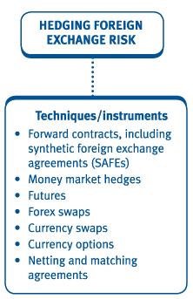
Hedging transaction risk and the internal techniques
Internal techniques to manage/reduce forex exposure should alwaysbe considered before external methods on cost grounds. Internaltechniques include the following:
Invoice in home currency
- One easy way is to insist that all foreign customers pay in your home currency and that your company pays for all imports in your home currency.
- However the exchange-rate risk has not gone away, it has just been passed onto the customer. Your customer may not be too happy with your strategy and simply look for an alternative supplier.
- Achievable if you are in a monopoly position, however in a competitive environment this is an unrealistic approach.
Leading and lagging
- If an importer (payment) expects that the currency it is due to pay will depreciate, it may attempt to delay payment. This may be achieved by agreement or by exceeding credit terms.
- If an exporter (receipt) expects that the currency it is due to receive will depreciate over the next three months it may try to obtain payment immediately. This may be achieved by offering a discount for immediate payment.
- The problem lies in guessing which way the exchange rate will move.
Matching
- When a company has receipts and payments in the same foreign currency due at the same time, it can simply match them against each other.
- It is then only necessary to deal on the forex markets for the unmatched portion of the total transactions.
- An extension of the matching idea is setting up a foreign currency bank account.
- Bilateral and multilateral netting and matching tools are discussed in more detail later in the chapter.
Decide to do nothing?
- The company would â€˜win some, lose someâ€™.
- Theory suggests that, in the long run, gains and losses net off to leave a similar result to that if hedged.
- In the short run, however, losses may be significant.
- One additional advantage of this policy is the savings in transaction costs.
Money market hedges
Characteristics
- The basic idea is to avoid future exchange rate uncertainty by making the exchange at todayâ€™s spot rate instead.
- This is achieved by depositing/borrowing the foreign currency until the actual commercial transaction cash flows occur:

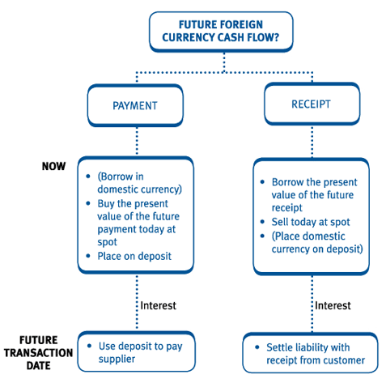

HedgingwithForwards
Hedging refers to managing risk to an extent that makes it bearable. In international trade and dealings foreign exchange play an important role. Fluctuations in the foreign exchange rate can have significant impact on business decisions and outcomes. Many international trade and business dealings are shelved or become unworthy due to significant exchange rate risk embedded in them. Historically, the foremost instrument used forex change rate risk management is the forward contract. Forward contracts are customized agreements between two parties to fix the exchange rate for a future transaction.

Hedging with Futures
Noting the shortcomings of the forward market, particularly the need and the difficulty in finding a counter party, the futures market came into existence. The futures market basically solves some of the shortcomings of the forward market. A currency futures contract is an agreement between two parties–a buyer and a seller–to buy or sell a particular currency at a future date, at a particular exchange rate that is fixed or agreed upon today.

Standardized Features of the Futures Contract and Liquidity
Contrary to the forward contract, the futures contract has a number off eatures that has been standardized. These standard features are necessary in order to increase the liquidity in the market, i.e. the number of matching transactions. In the practical world traders are faced with diverse conditions that need diverse actions (like the need to hedge different amounts of currency at different points of time in the future) such that matching transactions may be difficult t ofind. By standardizing the contract size(i.e. the amount) and the futures maturity, these different needs can be matched to some degree even though perhaps not perfectly.

Advantages
- Liquid and central market. Since futures contracts are traded on a central market, this increases the liquidity. There are many market participants and one may easily buy or sell futures. The problem of double co incidence of wants that could exist in the forward market is easily solved. A trader who has taken a position in the futures market can easily make an opposite transaction and close his or her position. Such easy exit is not a feature of the forward market though.
- Leverage. This feature is brought about by the margin system, where a tradertakesonalargepositionwithonlyasmallinitialdeposit.Ifthefuturescontractwith a value of RM1,000,000 has an initial margin of RM100,000 then a onepercent change in the futures price (i.e. RM10,000) would bring about a 10percentchangerelativetothetrader’sinitialoutlay.Thisamplificationofprofit(or losses) is called leverage. Leverage allows the trader to hedge big amounts with much smaller outlays.
- Position can be easily closed out. As mentioned earlier, any position taken in the futures market can be easily closed-out by making an opposite transaction. If a trader had sold 5 Rupee futures contracts expiring in December, then the trader could close that position by buying 5 December Rupee futures. In hedging, such closing-out of position is done close to the expected physical spot transaction. Profits or losses from futures would offset losses or profits from the spot transaction. Such offsetting may not be perfect though due to the imperfections brought about by the standardized features of the futures contract.
- Convergence. As the futures contract approach expiration, the futures price and spot price would tend to converge. On the day of expiration both prices must be equal. Converge nce is brought about by the activities of arbitrageurswho would move into profit if they observe price disparity between the future sandt he spot; buying in the cheaper market and selling the higher price done.

Disadvantages
- Legal obligation. The futures contract, just like the forward contract, is a legal obligation. Being a legal obligation it can some times be a problem to the business community. For example, if hedging is done through futures for a project that is still in the bidding process, the futures position can turn into a speculative position in the event the bidding turns out not successful.
- Standardized features. As mentioned earlier, since futures contracts have standardized features with respect to some characteristics like contract size, expiry date etc., perfect hedging may be impossible. Since over hedging is also generally not advisable, some part of the spot transactions will have to go unhedged.
- Initial and daily variation margins. This is a unique feature of the futures contract. A trader who wishes to take a position in the futures market must first pay an initial margin or deposit. This deposit will be returned when the trader closes his or her position. As mentioned earlier, futures contracts are marked tomarket–meaningtosaythatthefuturespositionistrackedonadailybasis-andthe trader would be required to pay up daily variation margins in the event of daily losses. The initial and daily variation margins can cause significant cash flow burde nont raders or hedgers.
- Forego favourable movements. In hedging using futures, any losses or profits in the spot transaction would be offset by profits or losses from the futures transaction. As in our earlier example, Bumiways sold Rupee futures in an anticipation of a Rupee depreciation. However, if Rupee were to appreciate, then Bumiways will have to forego such favourable movements.

The above shortcomings of futures contracts, particularly it being a legal obligation, with margin requirements and the need to forgo favourable movements prompted the development and establishment of a more flexible instrument, i.e.the option contracts and option markets.

Hedging using Options
A currency option may be defined as a contract between woparties–a buyer and aseller-where by the buyer of the option has the right but not the obligation, to buy or sell a specified currency at a specified exchange rate, at or before a specified date, from the seller of the option. While the buyer of option enjoys a right but not obligation, the seller of the option nevertheless has an obligation in the event the buyer exercises the given right.
There are two types of options:

- Call options–gives the buyer the right to buy a specified currency at a specified exchange rate, at or before a specified date.
- Put options–gives the buyer the right to sell a specified currency at a specified exchange rate, at or before a specified date.

Offshore
The term offshore refers to a location outside of one's home country. The term is commonly used in the banking and financial sectors to describe areas where regulations are different from the home country. Offshore locations are generally island nations, where entities set up corporations, investments, and deposits. Companies and individuals (typically those with a high net worth) may move offshore for more favorable conditions, including tax avoidance, relaxed regulations, or asset protection. Although offshore institutions can also be used for illicit purposes, they aren't considered illegal.

Types of Off shoring
There are several types of off shoring: Business, investing, and banking. We've gone into some detail about how these work below.

Off shoring Business
Off shoring is often referred to as outsourcing when it comes to business activity. This is the act of establishing certain business functions, such as manufacturing or call centers.
This is often done to take advantage of more favorable conditions in a foreign country, such as lower wage requirements or looser regulations, and can result in significant cost savings for the business. Companies with significant sales overseas, such as Apple and Microsoft, may take the opportunity to keep related profits in offshore accounts in countries with lower tax burdens.3

Offshore Investing
Offshore investing can involve any situation in which the offshore investors reside outside the nation in which they invest. This practice is mostly used by high-net-worth investors, as operating offshore accounts can be particularly high. It often requires opening accounts in the nation in which the investor wishes to invest. Some of the advantages of holding offshore accounts include tax benefits, asset protection, and privacy.5
Offshore investment accounts are generally opened in the name of a corporation, such as a holding company or a limited liability company (LLC) rather than an individual. This opens up investments to more favorable tax treatment
The primary downsides to offshore investing are the high costs and the increased regulatory scrutiny worldwide that offshore jurisdictions and accounts face. This makes offshore investing beyond the means of most investors. Offshore investors may also be scrutinized by regulators and tax authorities to make sure taxes are paid.

Offshore Banking
Offshore banking involves securing assets in financial institutions in foreign countries, which may be limited by the laws of the customer’s home nation—much like offshore investing. Think of the famed Swiss bank account— that James Bond-like account that puts rich people’s money out of reach of their own country’s government.
People and companies can use offshore accounts to avoid the unfavorable circumstances associated with keeping money in a bank in their home nation. Most entities do this to avoid tax obligations. Holding offshore bank accounts also makes it more difficult for them to be seized by authorities.
For those who work internationally, the ability to save and use funds in a foreign currency for international dealings can be a benefit. This often provides a simpler way to access funds in the needed currency without the need to account for rapidly changing exchange rates.
Pros
- Portfolio diversification
- Favorable tax treatment
- Asset protection
Cons
- More scrutiny
- Increased transparency from offshore jurisdictions
- Risk of working with the wrong professional
COMMERCIAL INVOICES :
The commercial invoice is one of the most important documents in international trade and ocean freight shipping. It is a legal document issued by the seller (exporter) to the buyer (importer) in an international transaction and serves as a contract and a proof of sale between the buyer and seller.
Unlike the Bill of Lading, the commercial invoice does not indicate the ownership of goods nor does it carry a title to the goods being sold. It is, however, required for customs clearance purposes to calculate and assess the duties and taxes due.
The commercial invoice details the price(s), value, and quantity of the goods being sold. It should also include the trade or sale conditions agreed upon by both buyer and seller of the transaction being carried out.
It may also be required for payment purposes (such as in the event of payment via Letter of Credit and may need to be produced by the buyer to its bank to instruct the release of funds to the seller for payment.

commercial invoice models:
There are plenty of commercial invoice templates and samples to choose from online. While there is no fixed commercial invoice format, most of the information required is very similar and standardized across all templates. Whichever template you choose, ensure that the following details are included:

Information related to the transaction
- Invoice number
- Invoice date
- Order number
- Total sale amount
- Currency
- Payment instructions

Information related to the exporter and importer
- Exporter/seller information (name, address, phone number, etc.)
- Exporter/seller’s tax identification number (eg. VAT, EORI, etc.)
- Importer/buyer information (name, address, phone number, etc.)
- Importer/buyer’s tax identification number (eg. VAT, EORI, etc.)
- Notify party’s information

Information related to the shipping of the merchandise
- Bill of Lading number
- Forwarding agent
- HS code
- Clear description of goods (no. of packages, units, weight, etc.)
- Incoterm under which the merchandise has been sold
- Origin of merchandise
- Insurance
- Date of exportation, means of transport, and final destination
- Shipper’s signature

Bill of Exchange
According to the Negotiable Instruments Act 1881, a bill of exchange is defined as “an instrument in writing containing an unconditional order, signed by the maker, directing a certain person to pay a certain sum of money only to, or to the order of a certain person or to the bearer of the instrument”.

Features of Bill of Exchange
- It is important to have a bill of exchange in writing
- It must contain a confirm order to make a payment and not just the request
- The order should not have any condition
- The bill of exchange amount should be definite
- Fixed date for the amount to be paid
- The bill must be signed by both the drawee and the drawer
- The amount stated on the bill should be paid on-demand or on the expiry of a fixed time
- The amount is paid to the beneficiary of the bill, specific person, or against a definite order

Types of Bill of Exchange
- Documentary Bill- In this, the bill of exchange is supported by the relevant documents that confirm the genuineness of sale or transaction that took place between the seller and buyer.
- Demand Bill- This bill is payable when it demanded. The bill does not have a fixed date of payment, therefore, the bill has to be cleared whenever presented.
- Usance Bill- It is a time-bound bill which means the payment has to be made within the given time period and time.
- Inland Bill- An Inland bill is payable only in one country and not in any other foreign country. This bill is opposite to the foreign bill.
- Clean Bill- This bill does not have any proof of a document, so the interest is comparatively higher than the other bills.
- Foreign Bill- A bill that can be paid outside India is termed as a foreign bill. Two examples of a foreign bill are an export bill and import bill.
- Accommodation Bill- A bill that is sponsored, drawn, accepted without any condition is known as an accommodation bill.
- Trade Bill- This kind of bill is specially related only to trade.
- Supply Bill- The bill that is withdrawn by the supplier or contractor from the government department is known as the supply bill.

Advantages of Bill of Exchange
- Legal Document- It is a legal document, and if the drawee fails to make the payment, it will be easier for the drawer to recover the amount legally.
- Discounting Facility- In cases where the drawer is in immediate need of money, the bill can be converted into cash by discounting it from a bank by paying some nominal charges.
- Endorsement Possible- This bill of exchange can be exchanged from one individual to another for the adjustment of the debt.

Parties of Bill of Exchange
A bill of exchange has three parties:
(1) Drawer:
- The drawer is the maker of a bill of exchange.
- The bill is signed by Drawer.
- A creditor who is entitled to receive payment from the debtor can draw a bill of exchange.
(2) Drawee:
- Drawee is the person upon whom the bill of exchange is drawn.
- Drawee is the debtor who has to pay the money to the drawer.
- He is also known as ‘Acceptor’.
(3) Payee:
- The payee is the person to whom payment has to be made.
- The payee may be the drawer himself or a third party.

